Following are the steps I followed to run pharma network in my system after completion of coding and configuration:

Step 1 : goto path containing network folder then run “sh fabricNetwork.sh up”

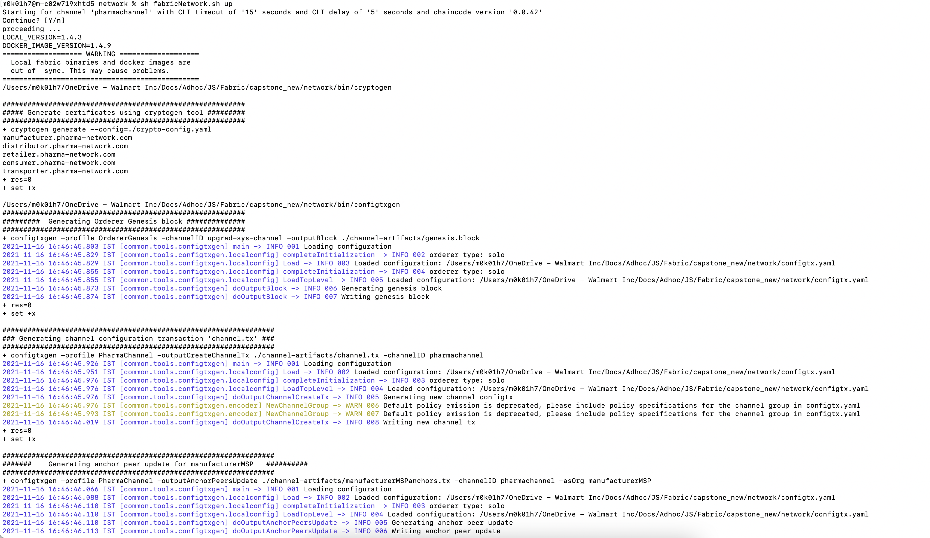

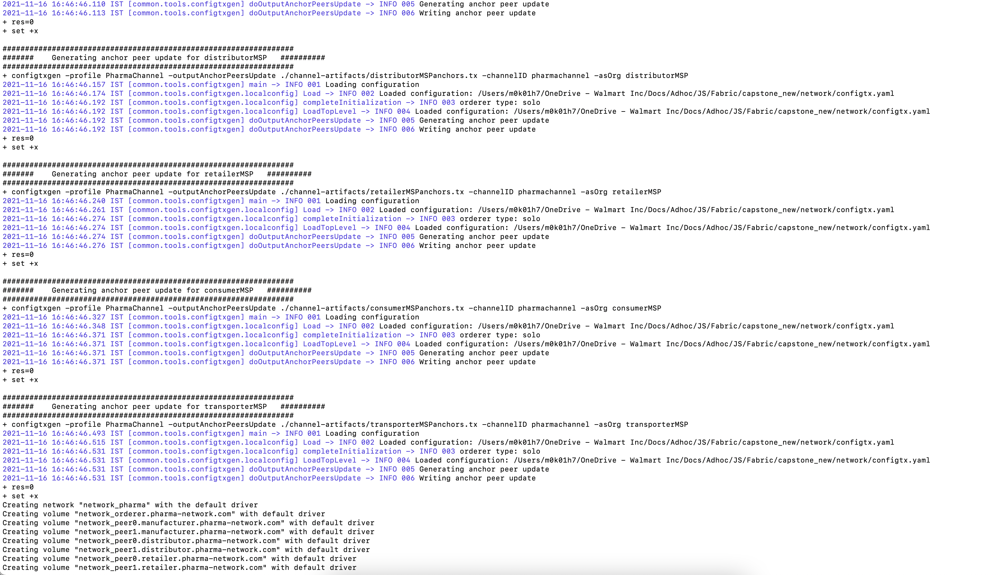

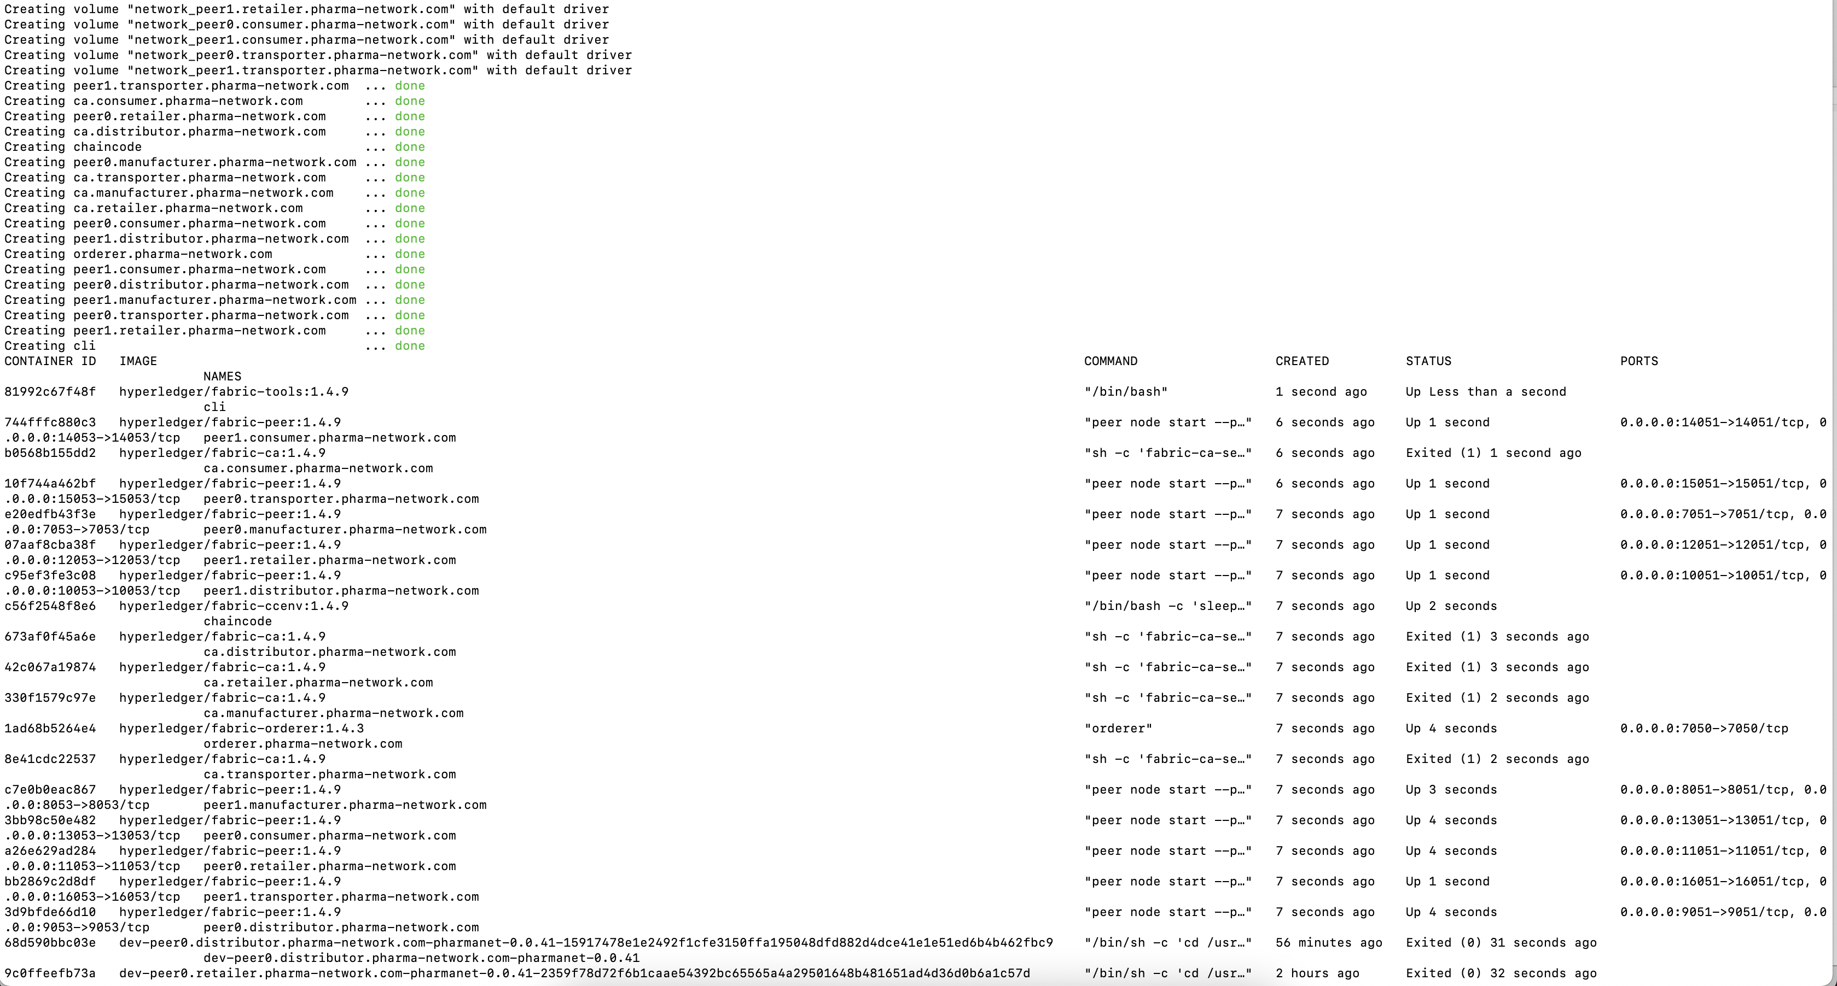

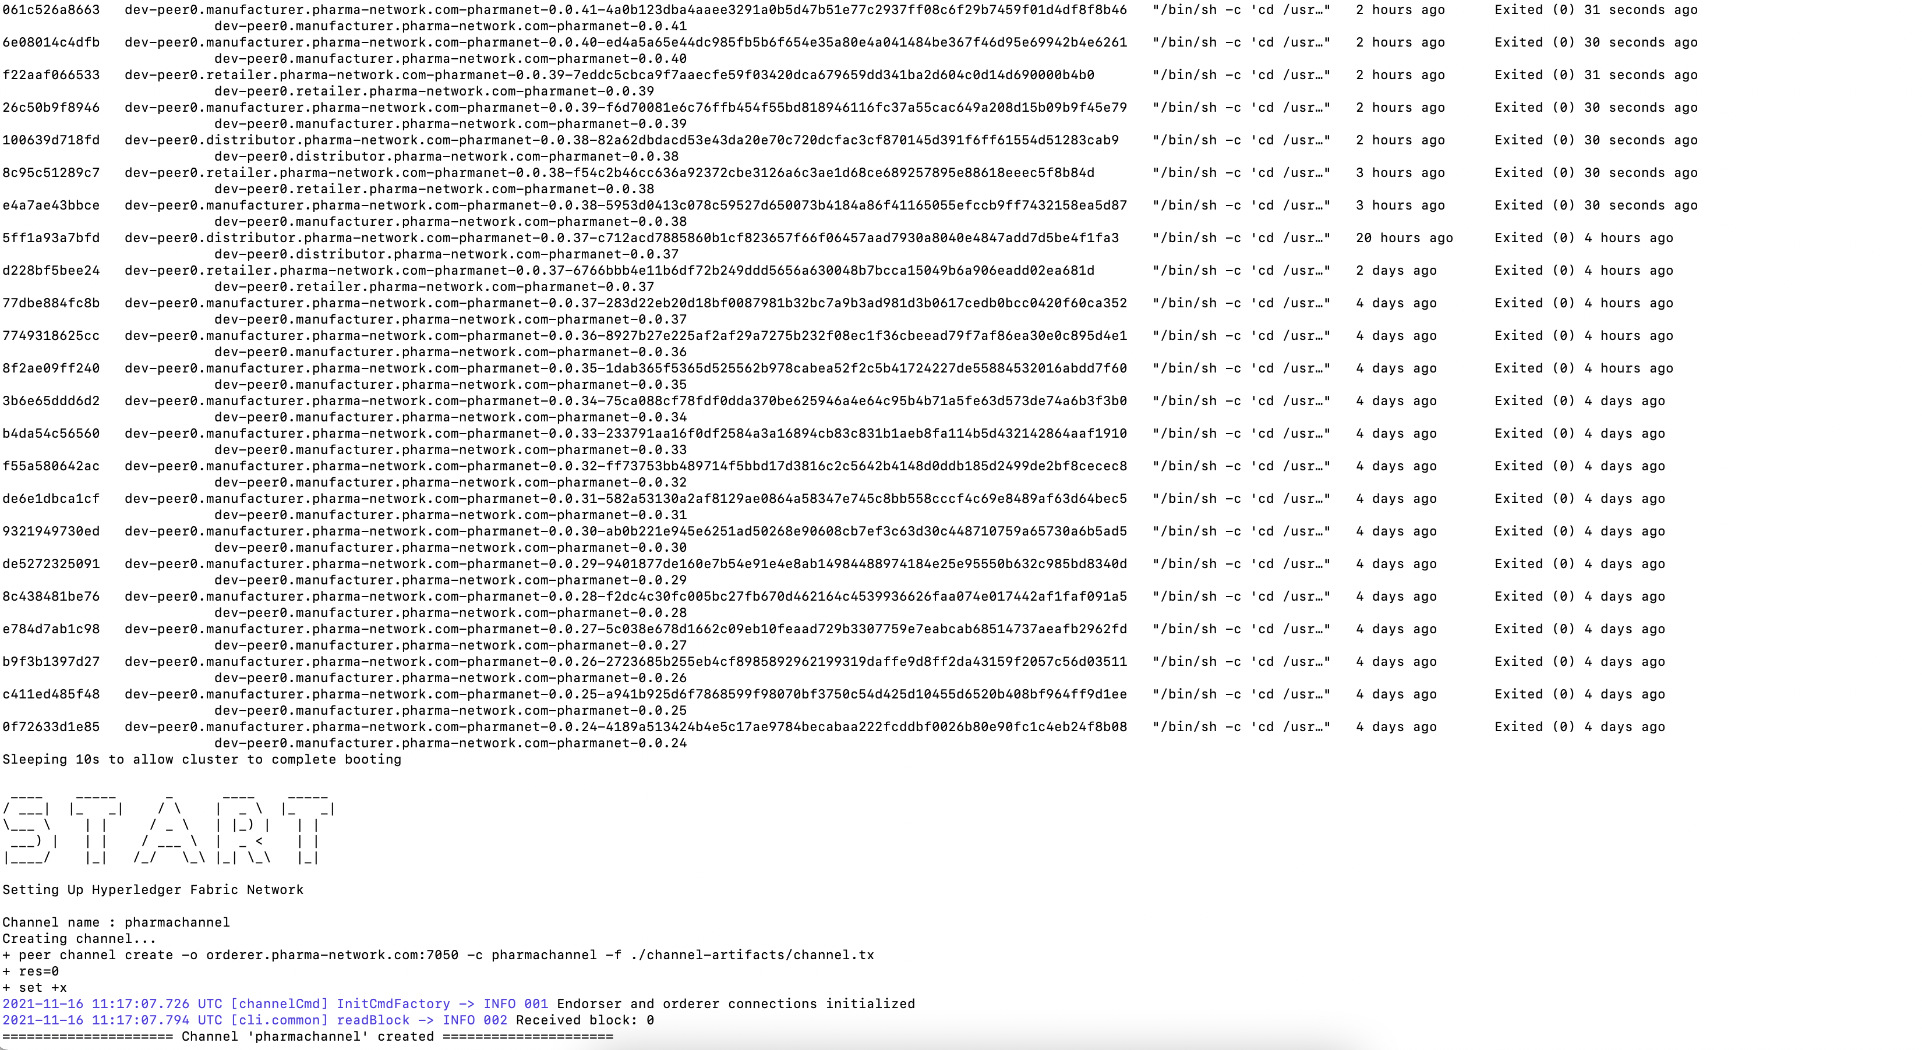

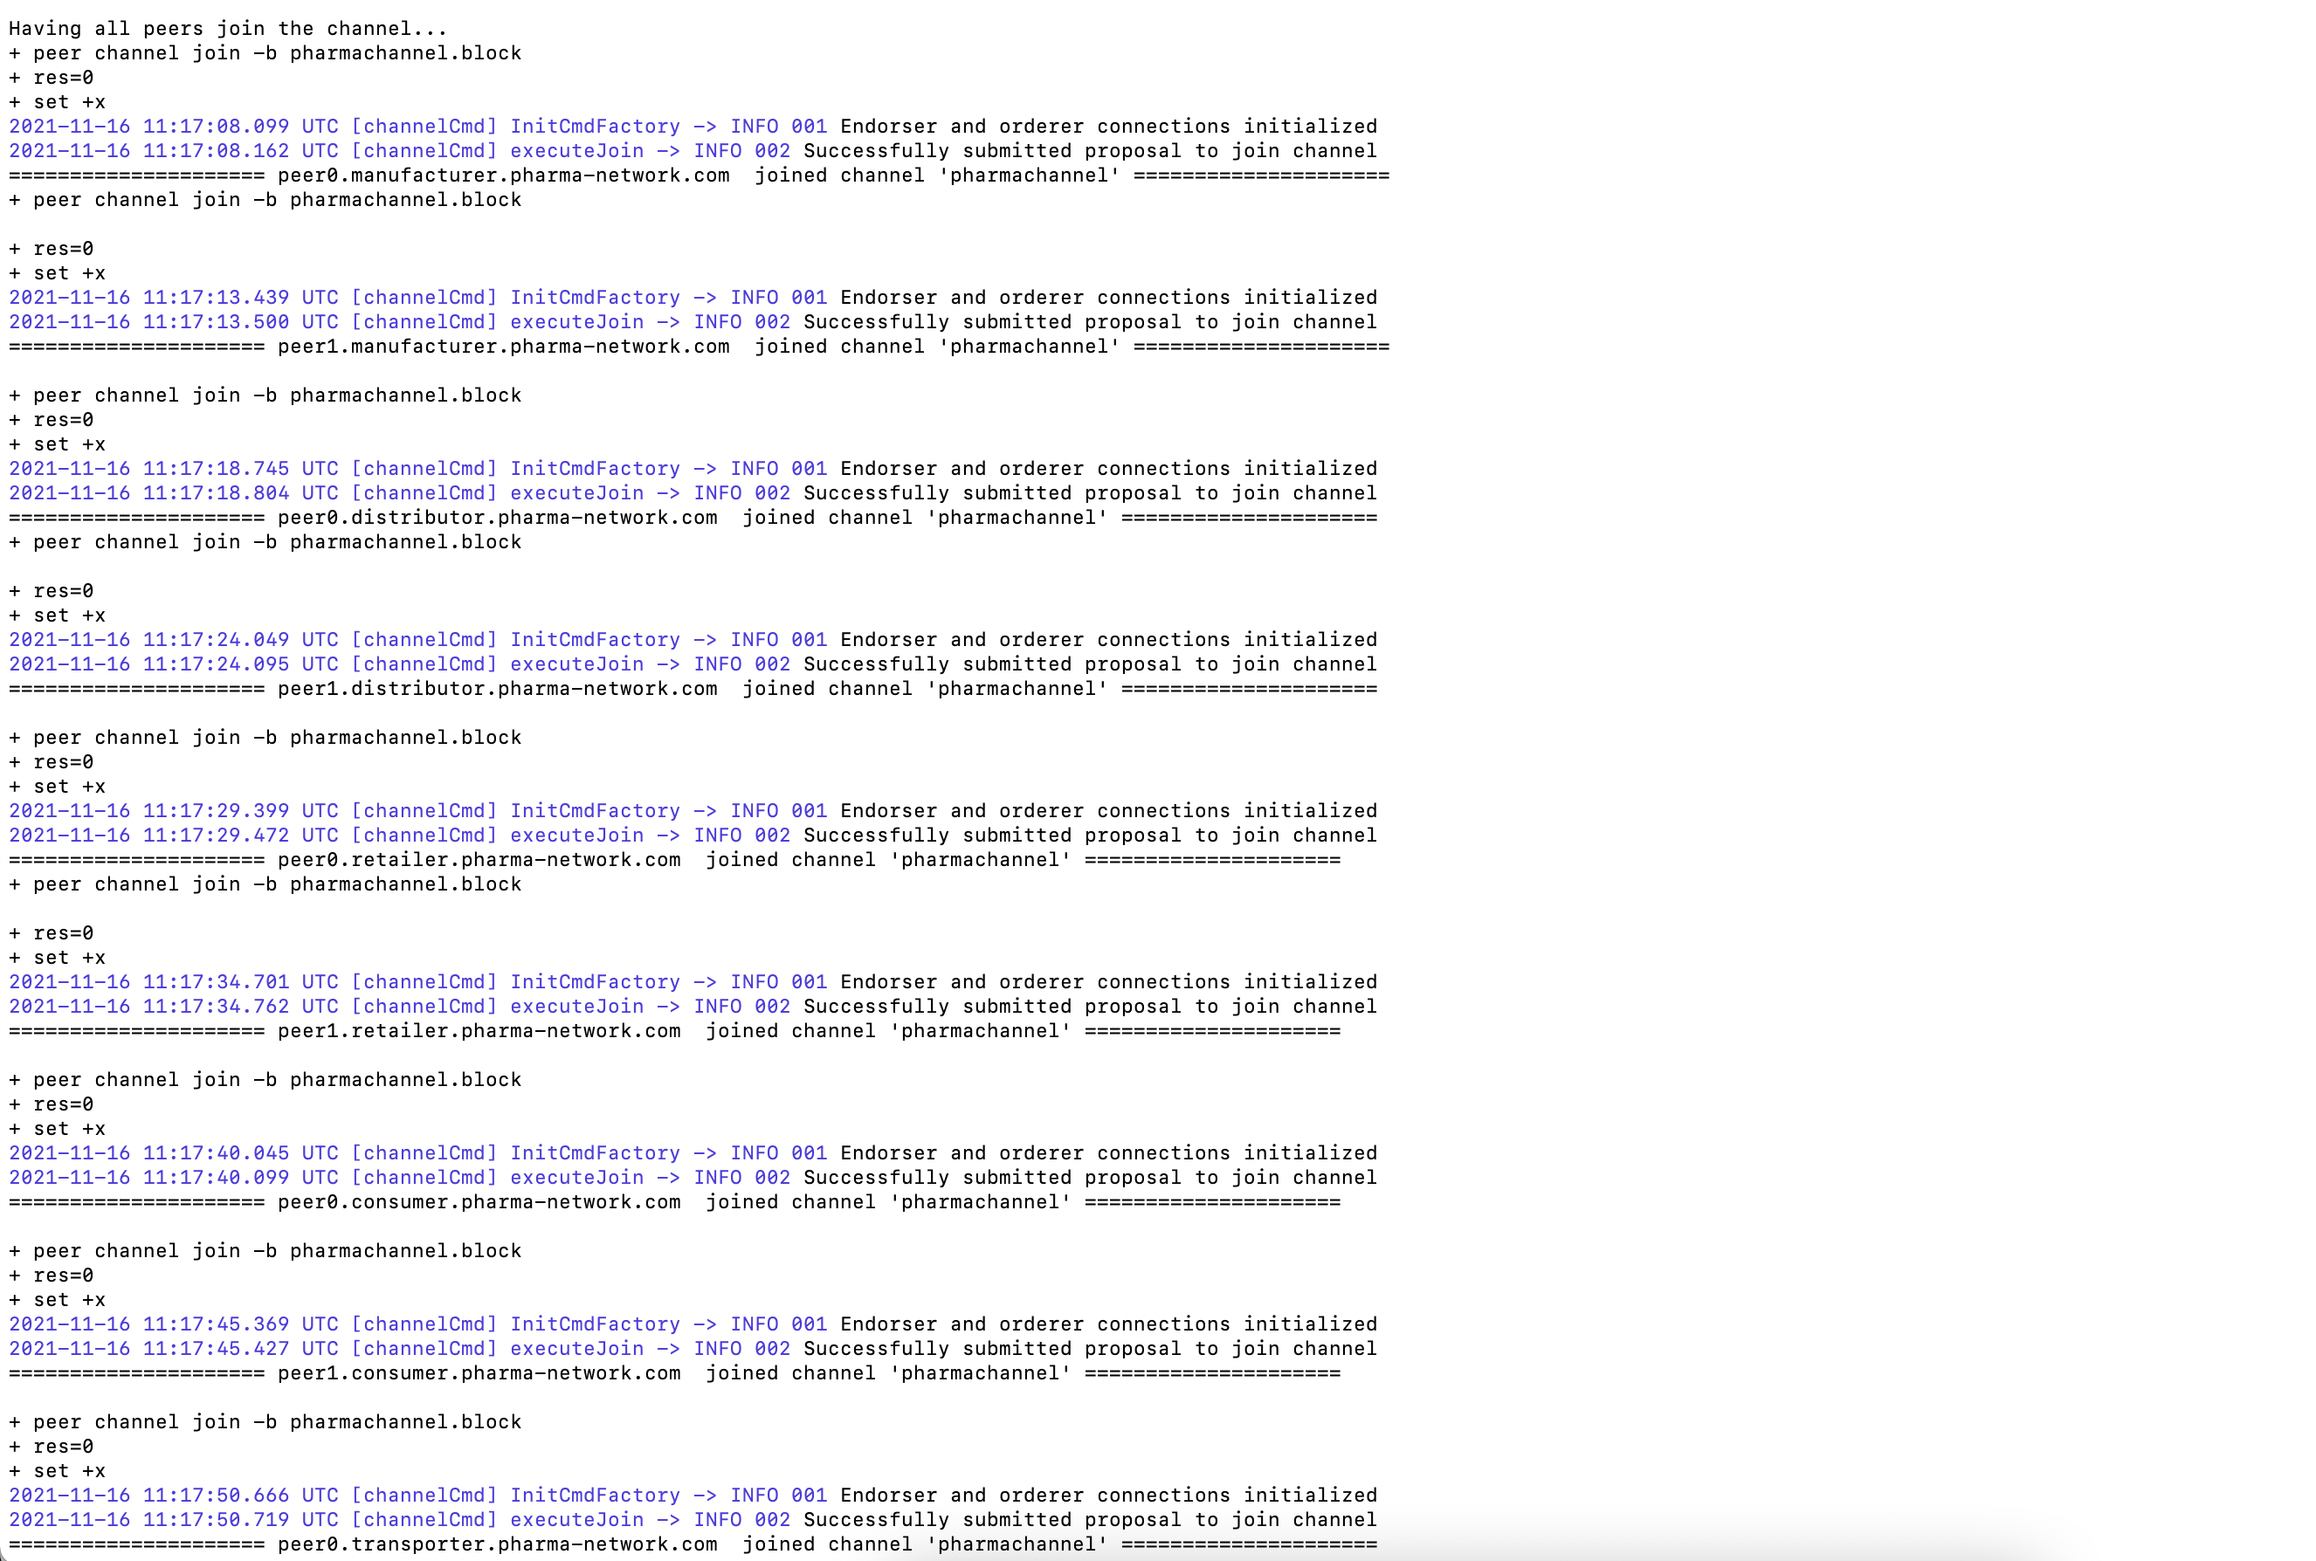

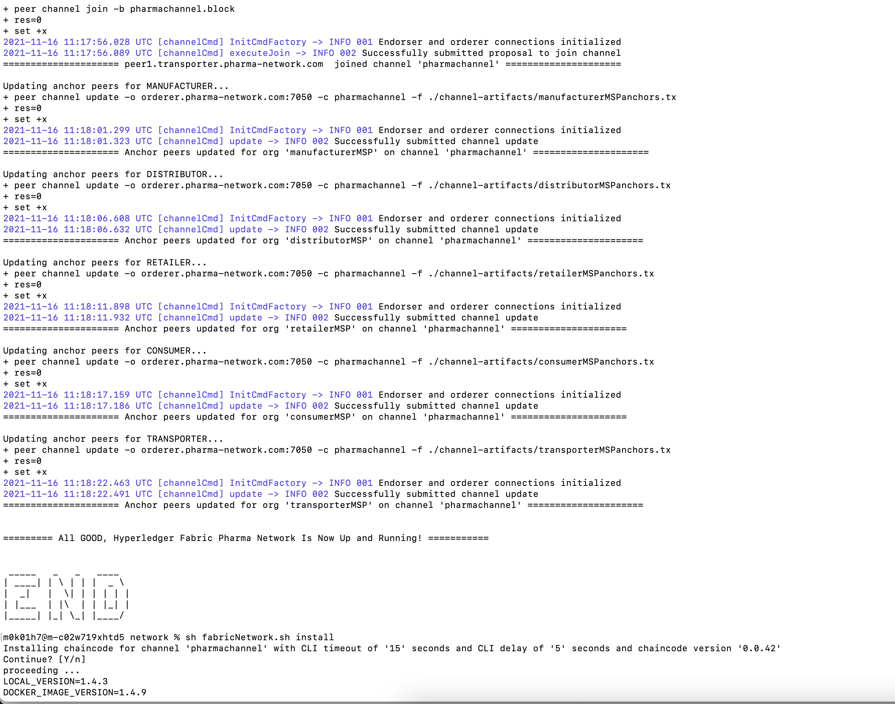

Step 2: Above screenshot also mentions install and instantiation of chaincode with command “sh fabricNetwork.sh install” on same ./network folder

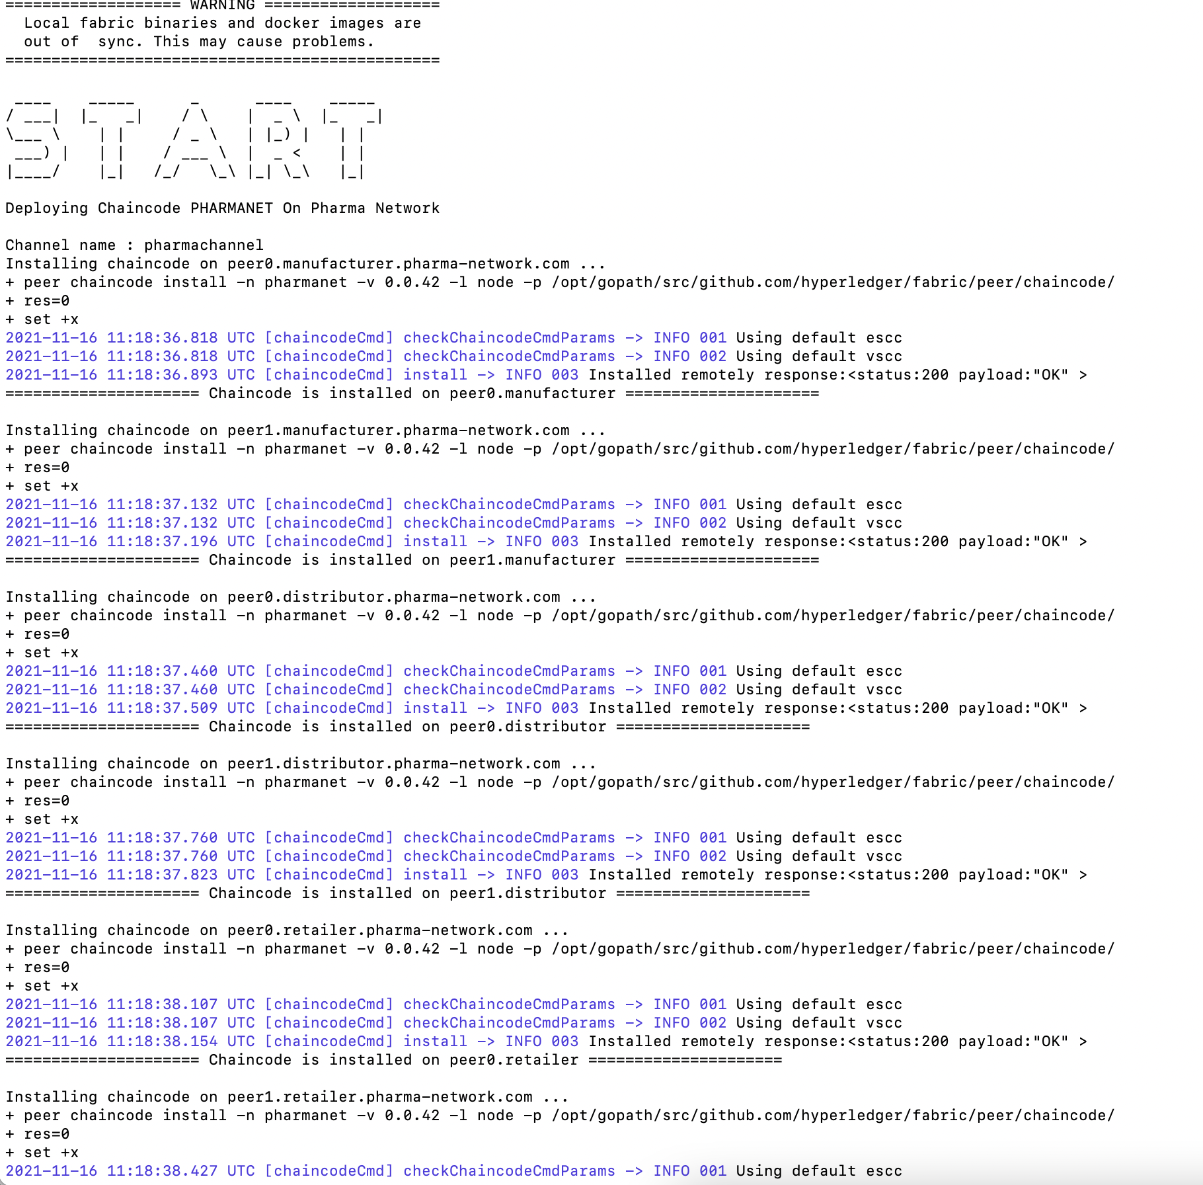

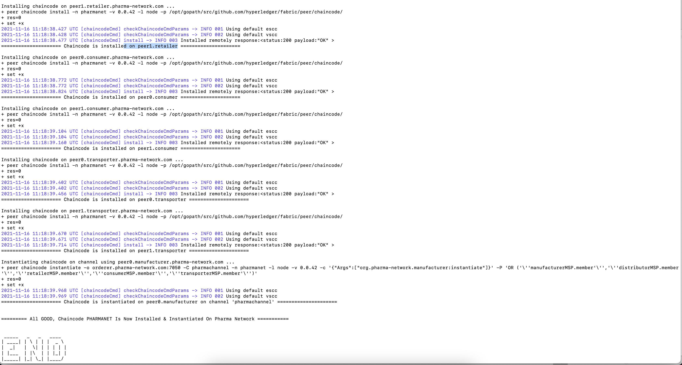

Hence, successfully installed and instantiated Chaincode

Now need to enter into application folder and run command “node .” that runs the express server on pre-configured port 3000



Below Steps goes through the test cases created and ran using postman,

Creating Identity for all Organizations Retailer, Manufacturer, Distributor, Consumer, Transporter:

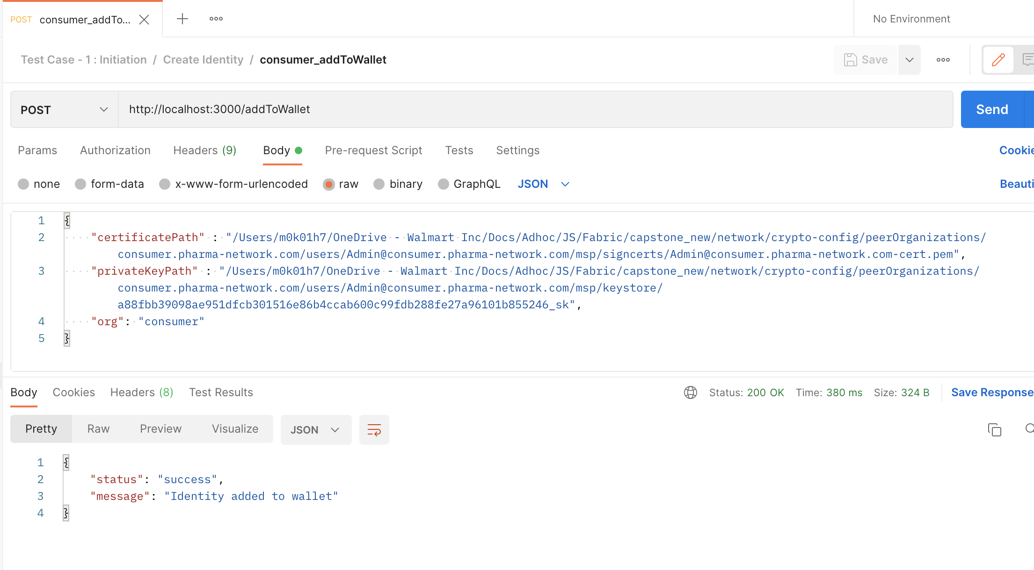

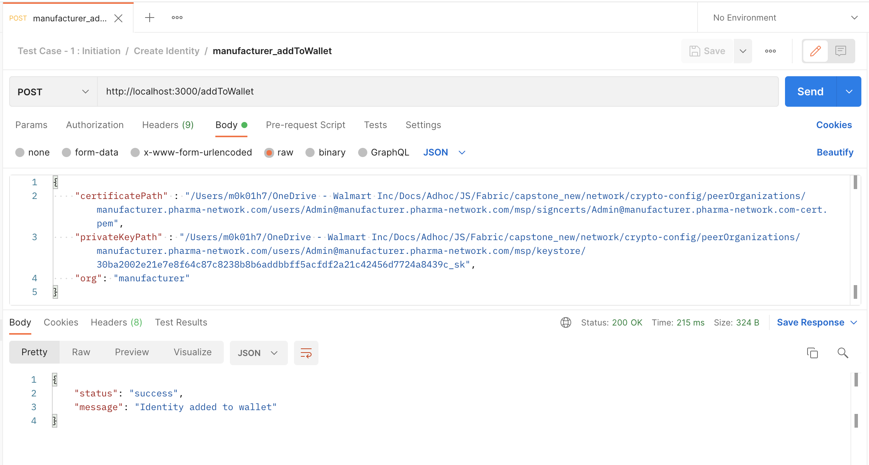

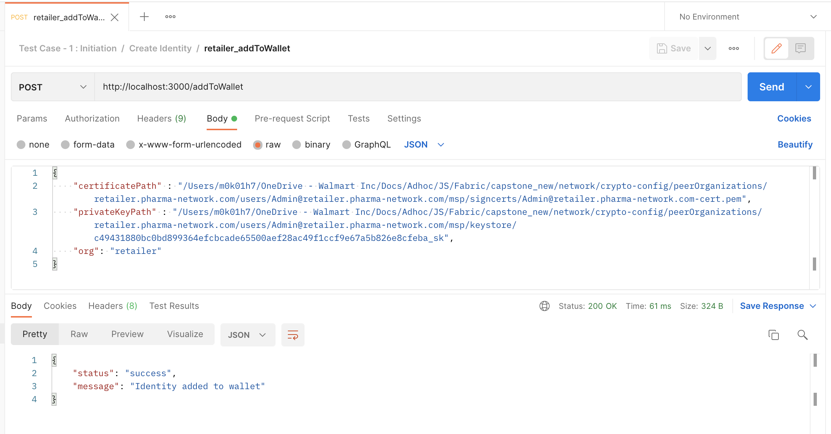

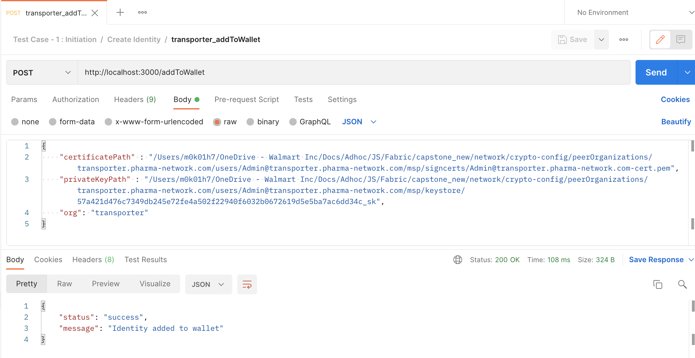

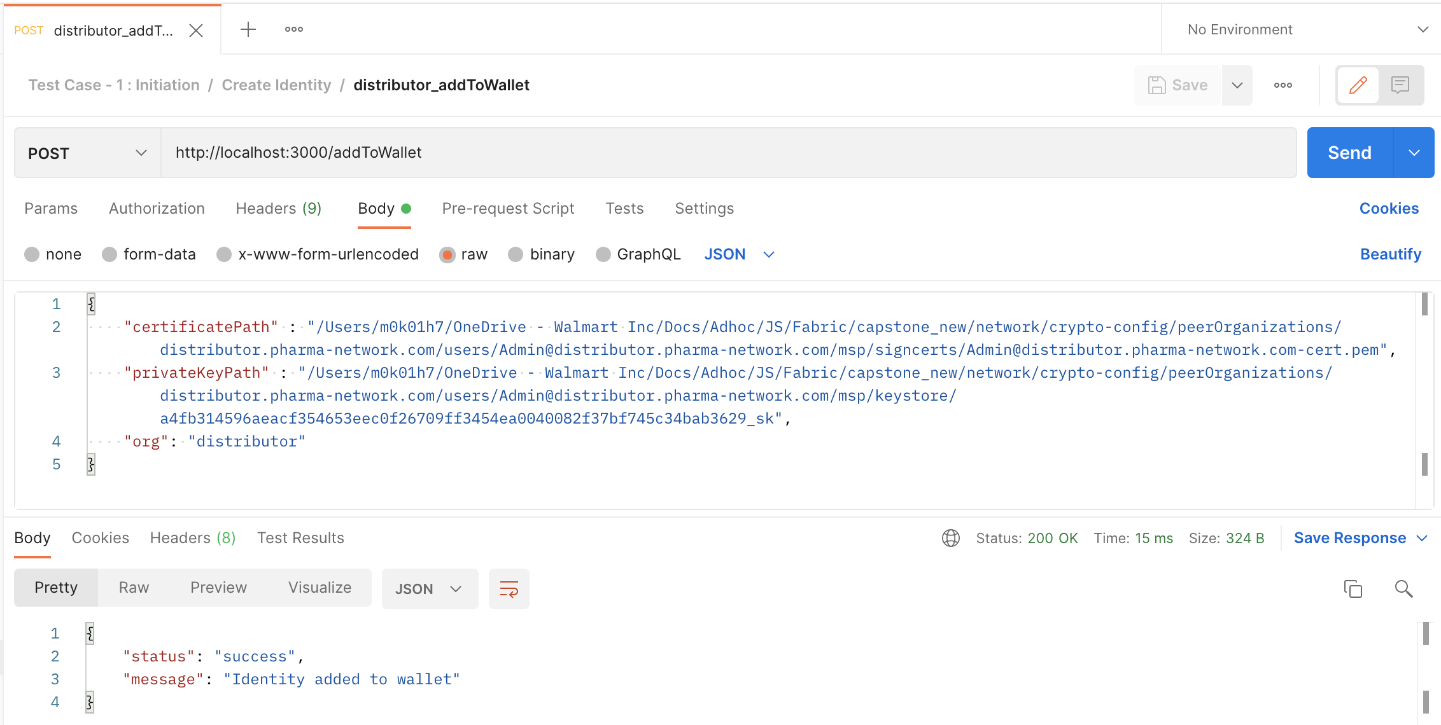

Below Screenshot depicts the created identity folder,

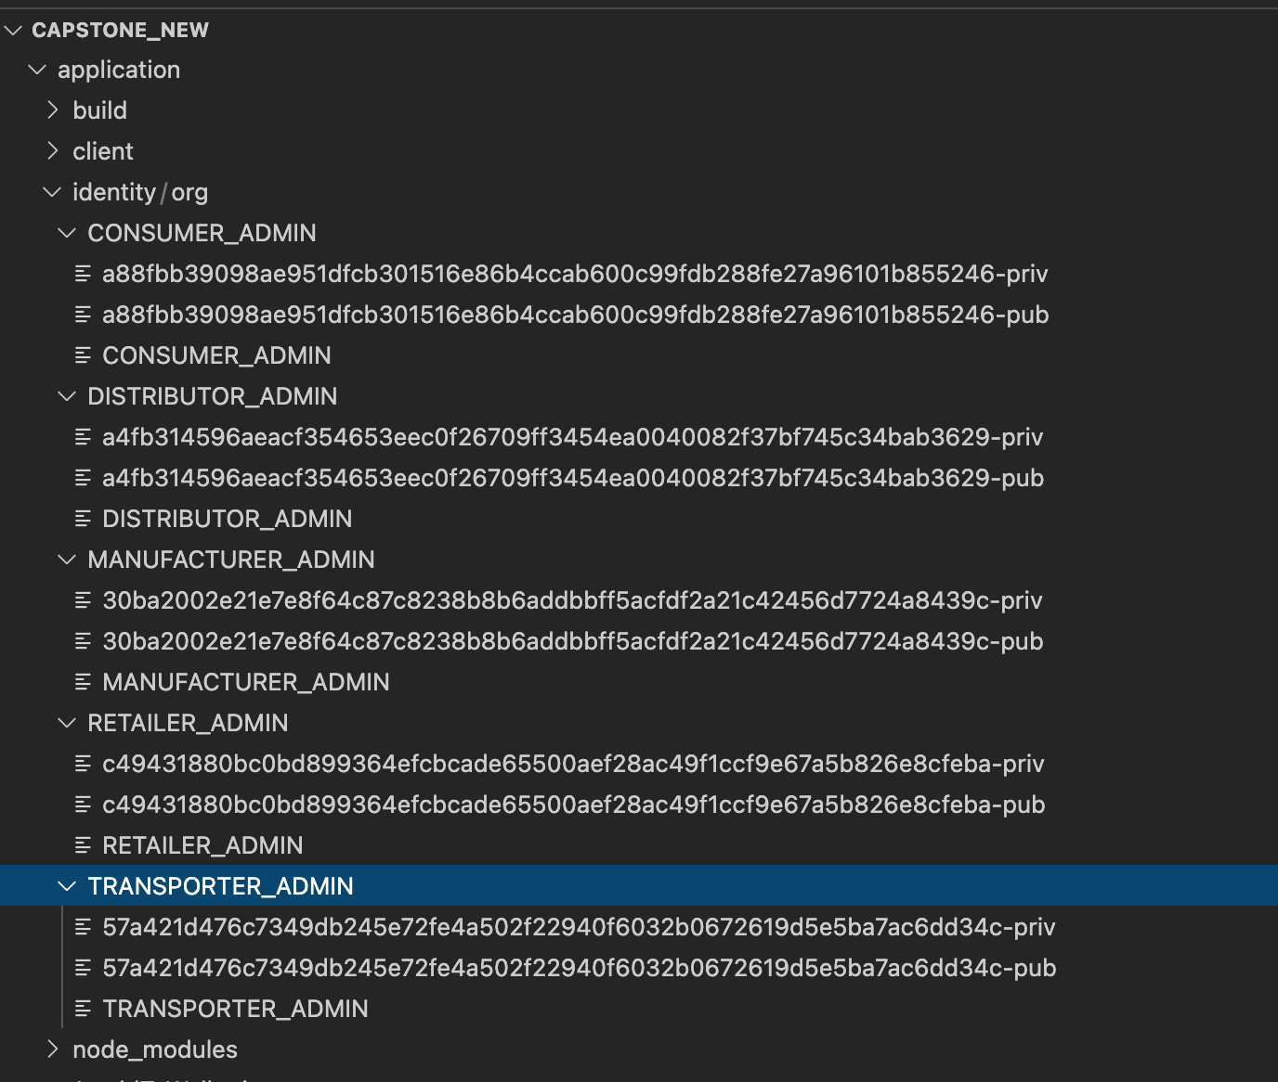

**Test Case 1 : Initiation**

Registration of Manufacturer - Sun Pharma:

curl --location --request POST 'http://localhost:3000/registerManufacturer' \

--header 'Content-Type: application/json' \

--data-raw '{

"companyCRN" : "MAN001",

"companyName" : "Sun Pharma",

"location": "Chennai"

}'

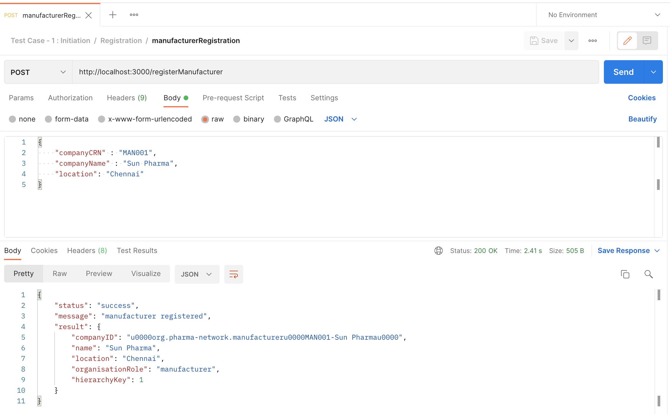

Registration of Transporter – FedEx:

curl --location --request POST 'http://localhost:3000/registerTransporter' \

--header 'Content-Type: application/json' \

--data-raw '{

"companyCRN" : "TRA001",

"companyName" : "FedEx",

"location": "Delhi"

}'

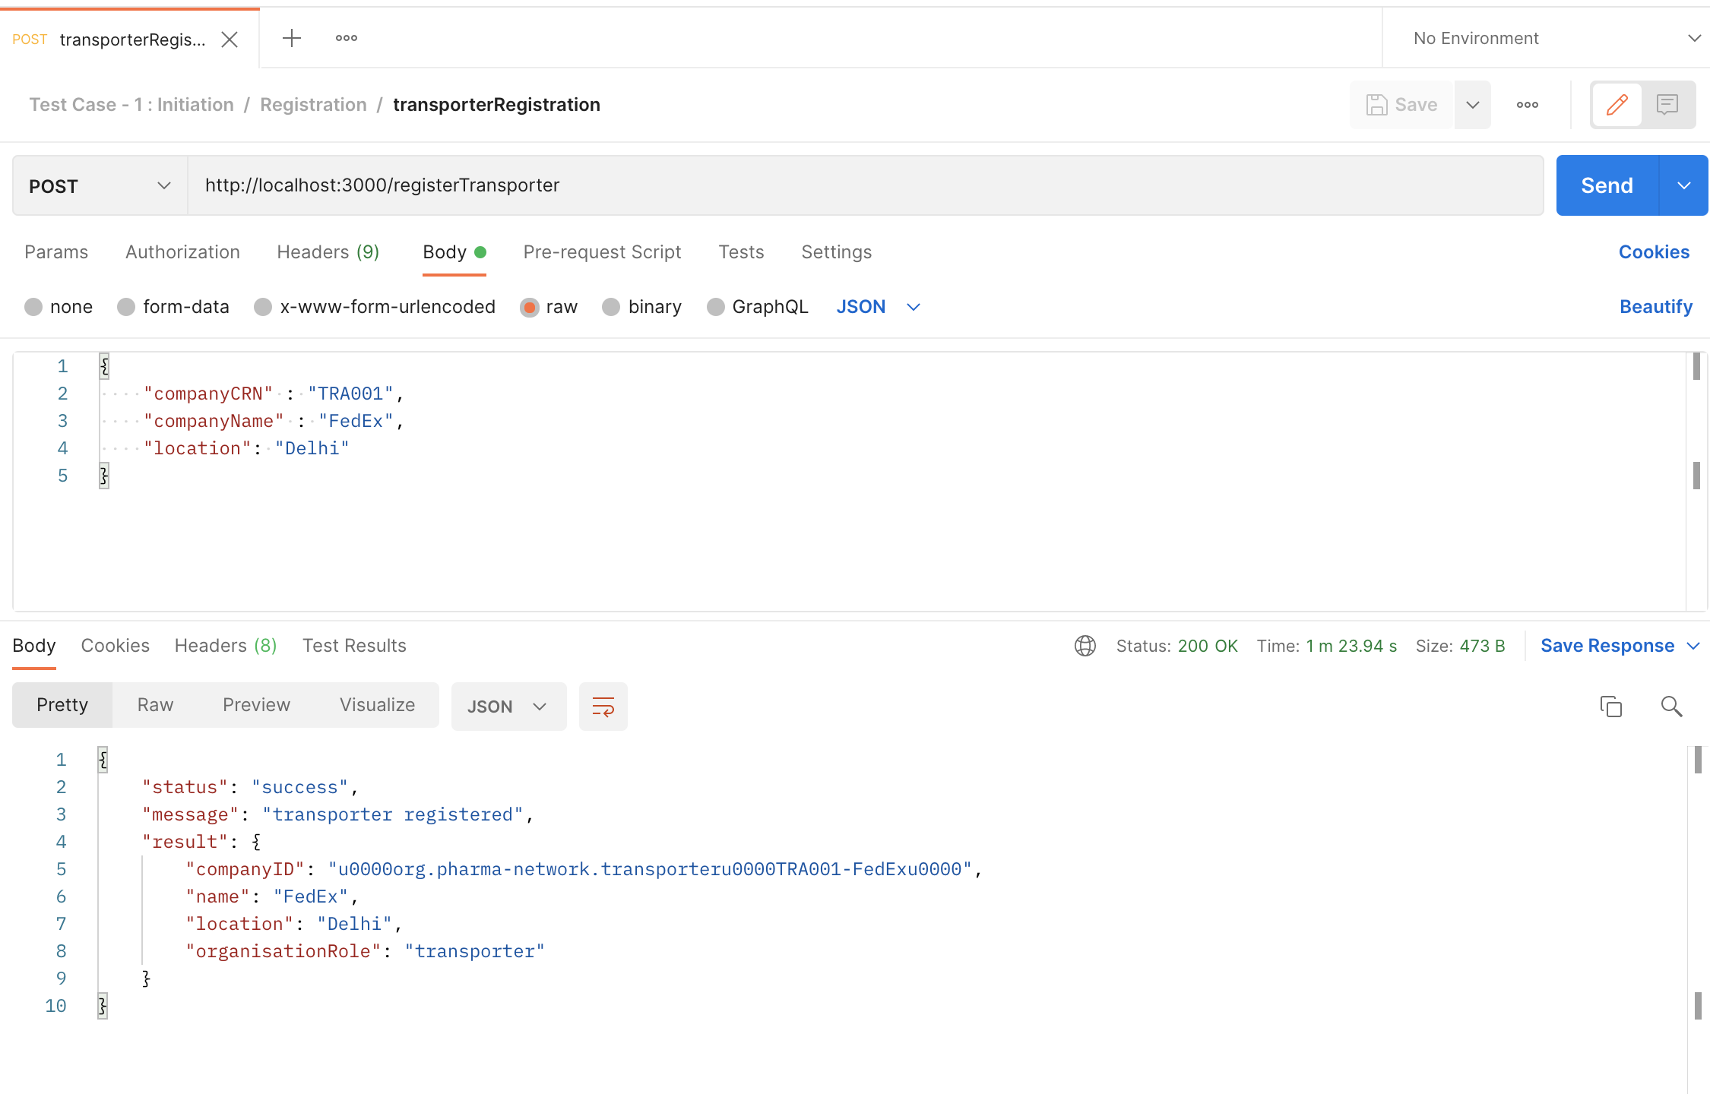

Registration of Transporter – Blue Dart:

curl --location --request POST 'http://localhost:3000/registerTransporter' \

--header 'Content-Type: application/json' \

--data-raw '{

"companyCRN" : "TRA002",

"companyName" : "Blue Dart",

"location": "Bangalore"

}'

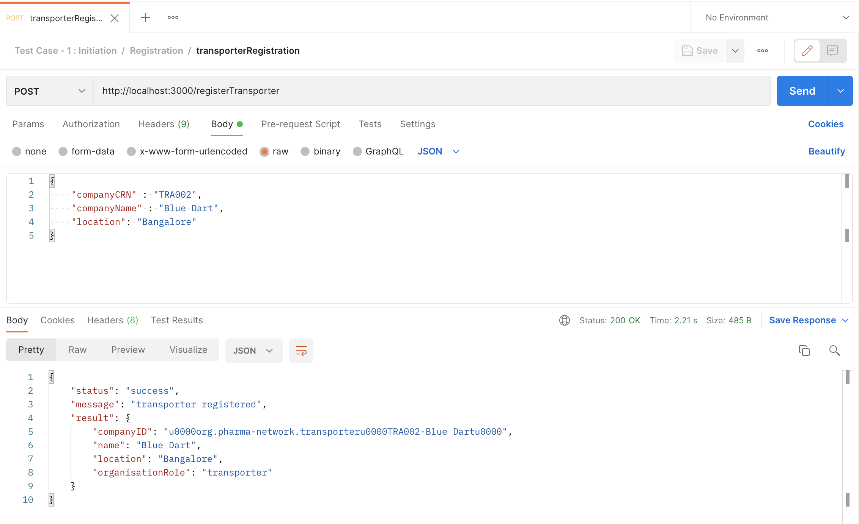

Registration of Distributor – VG Pharma:

curl --location --request POST 'http://localhost:3000/registerDistributor' \

--header 'Content-Type: application/json' \

--data-raw '{

"companyCRN" : "DIST001",

"companyName" : "VG Pharma",

"location": "Vizag"

}'

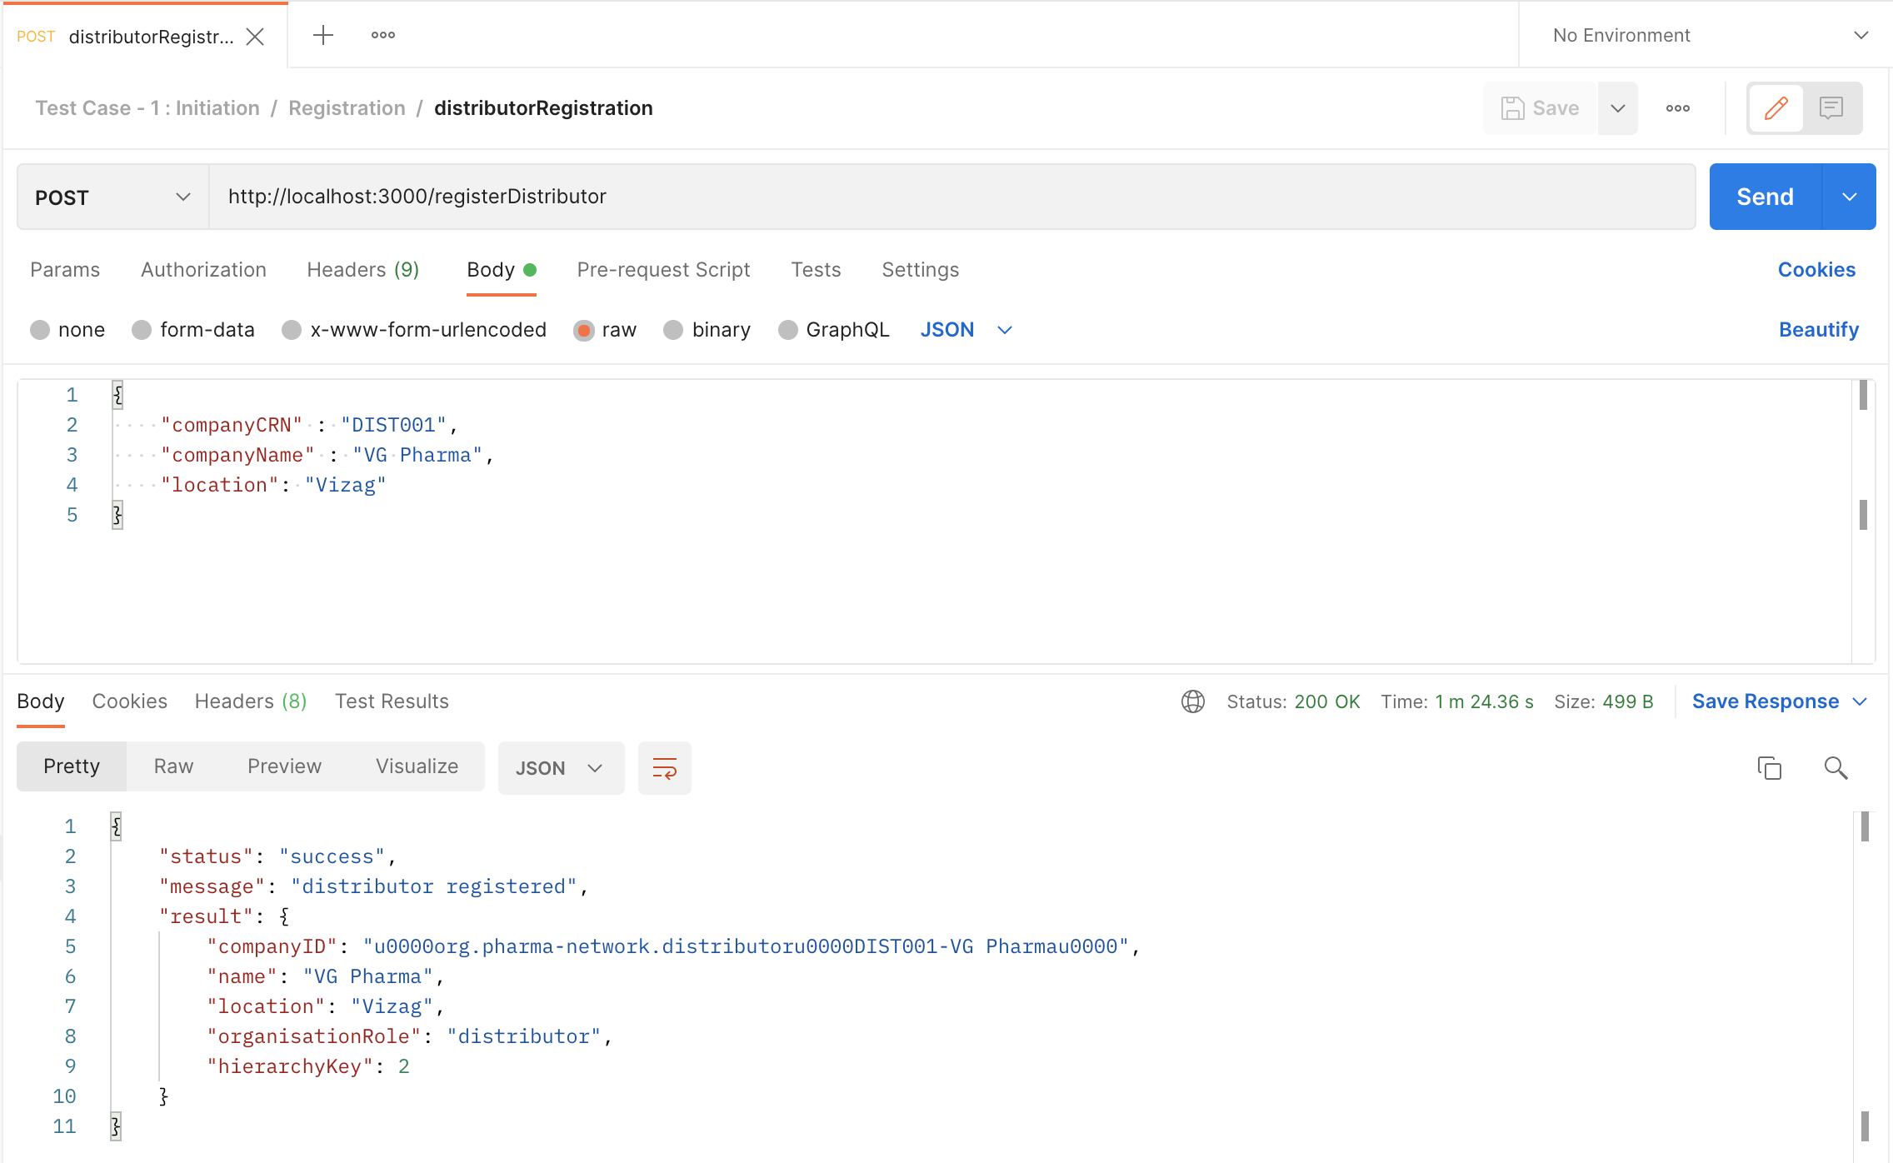

Registration of Retailer – upgrad:

curl --location --request POST 'http://localhost:3000/registerRetailer' \

--header 'Content-Type: application/json' \

--data-raw '{

"companyCRN" : "RET002",

"companyName" : "upgrad",

"location": "Mumbai"

}'

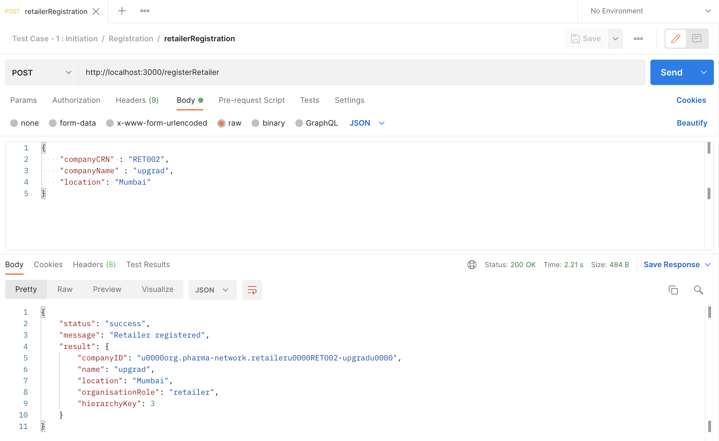

Adding Drug paracetamol with serial no from 001 to 004,

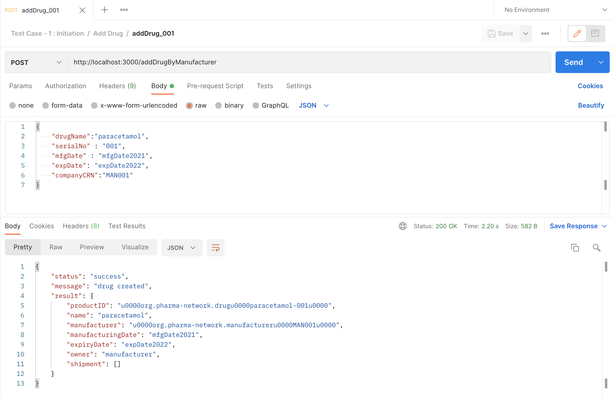

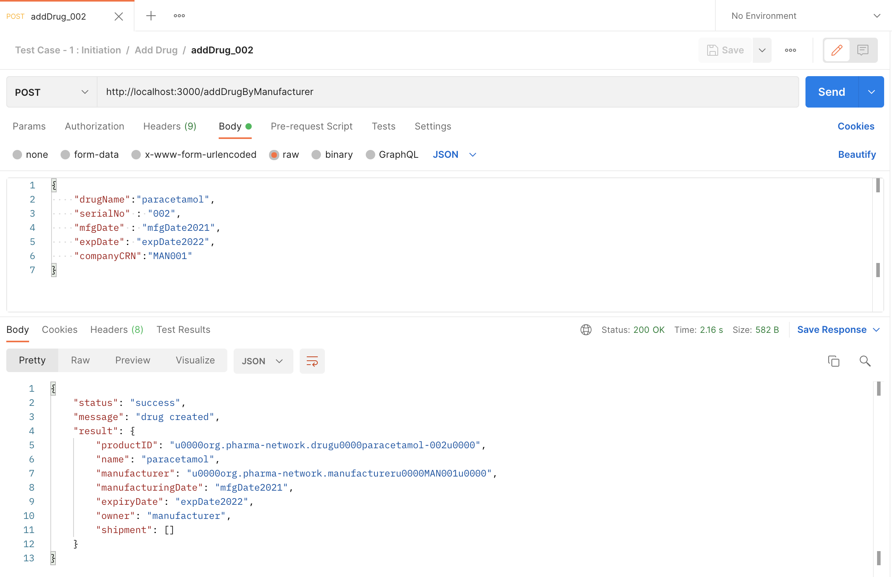

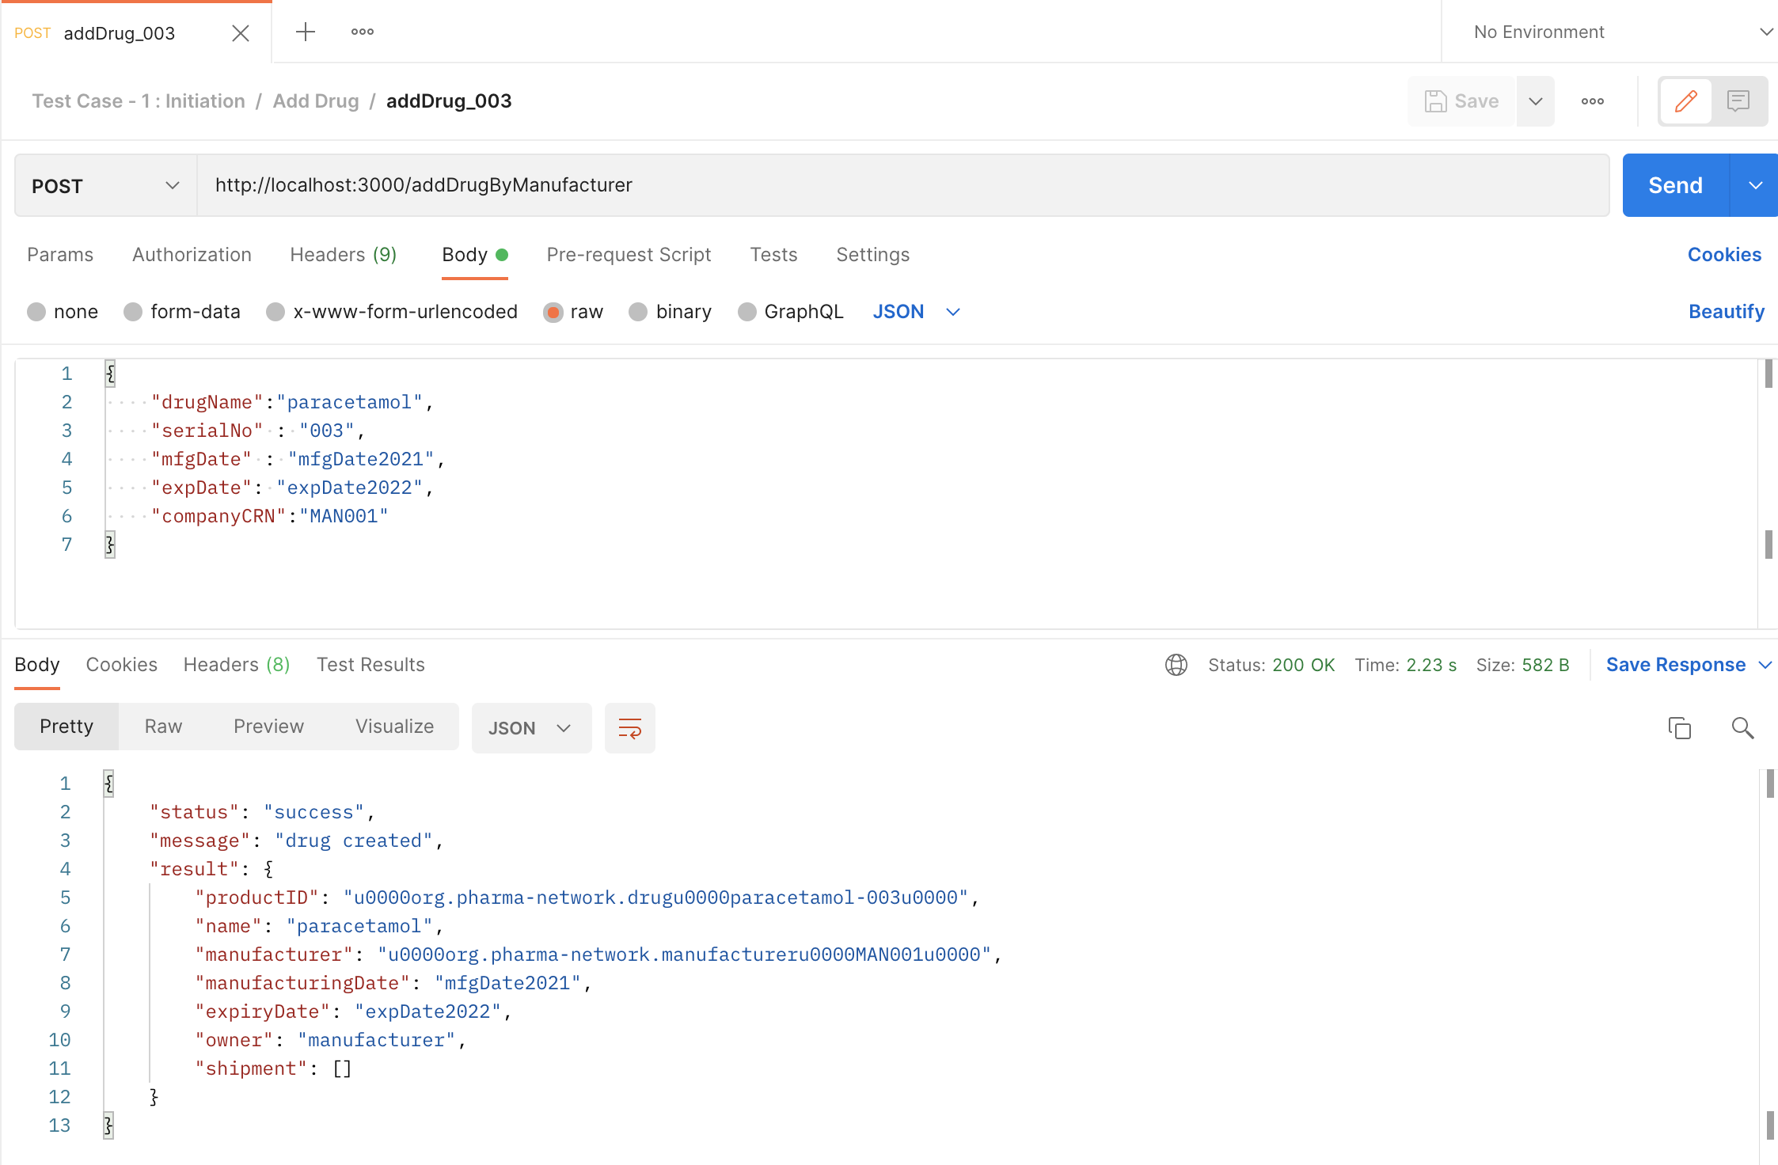

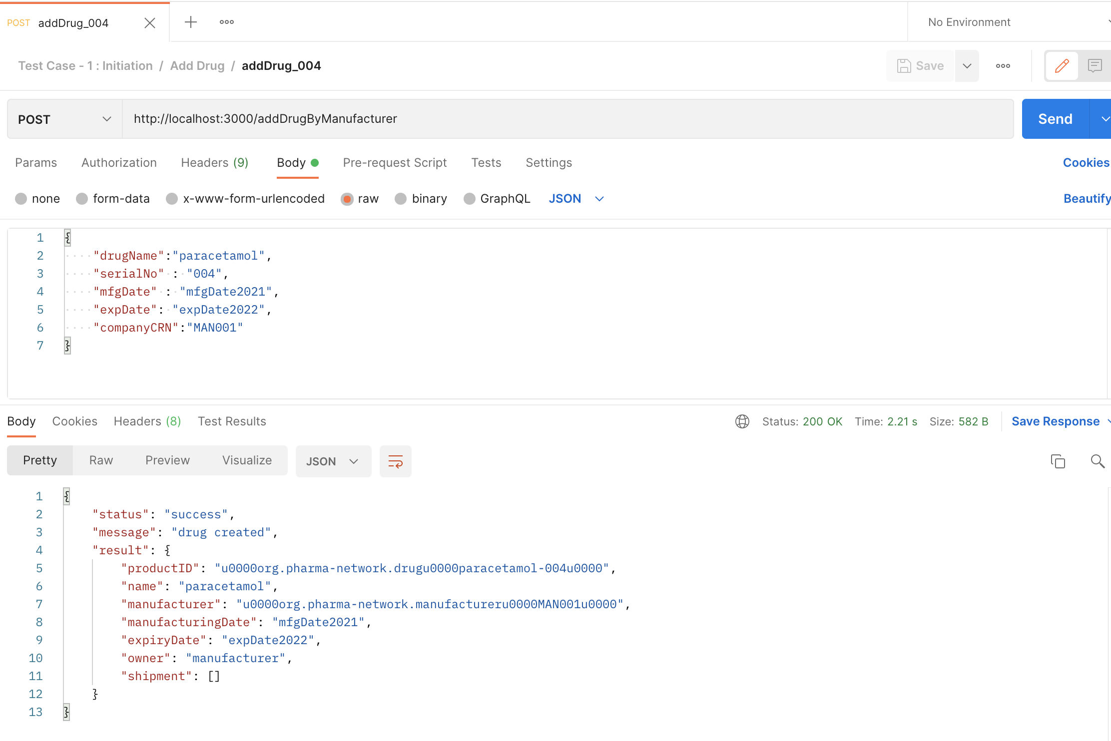

Test Case -2: Supply Chain

Part a:

Purchase Order created by VG Pharma,

curl --location --request POST 'http://localhost:3000/createPOByDistributor' \

--header 'Content-Type: application/json' \

--data-raw '{

"buyerCRN" : "DIST001",

"sellerCRN" : "MAN001",

"drugName": "paracetamol",

"quantity" : "3"

}'

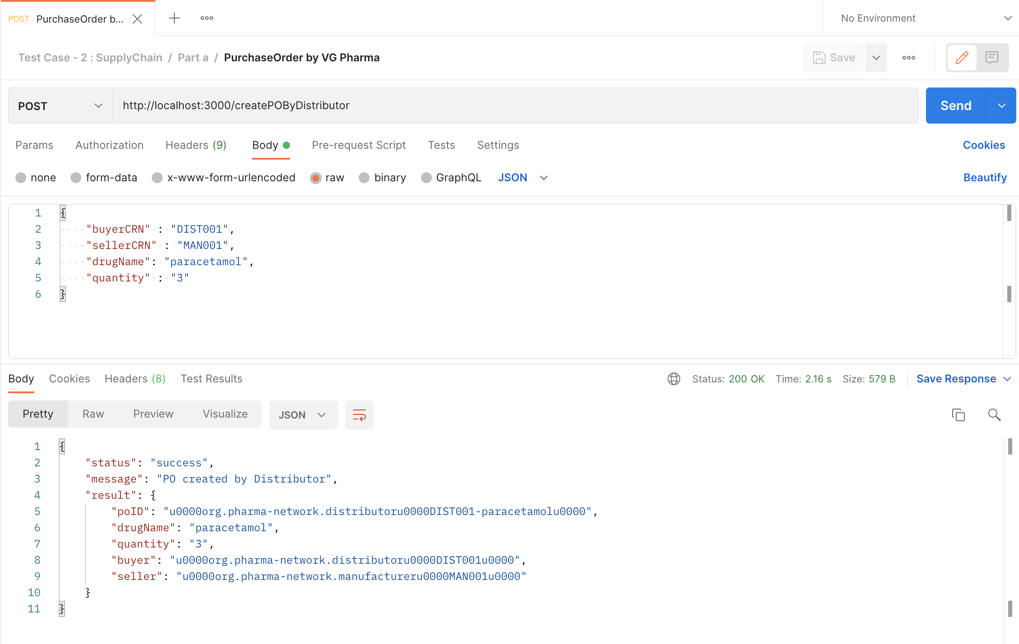

Shipment created by Sun Pharma,

curl --location --request POST 'http://localhost:3000/createShipmentByManufacturer' \

--header 'Content-Type: application/json' \

--data-raw '{

"buyerCRN" : "DIST001",

"drugName" : "paracetamol",

"listOfAssets": "[\"paracetamol-001\",\"paracetamol-002\",\"paracetamol-003\" ]",

"transporterCRN" : "TRA001"

}'

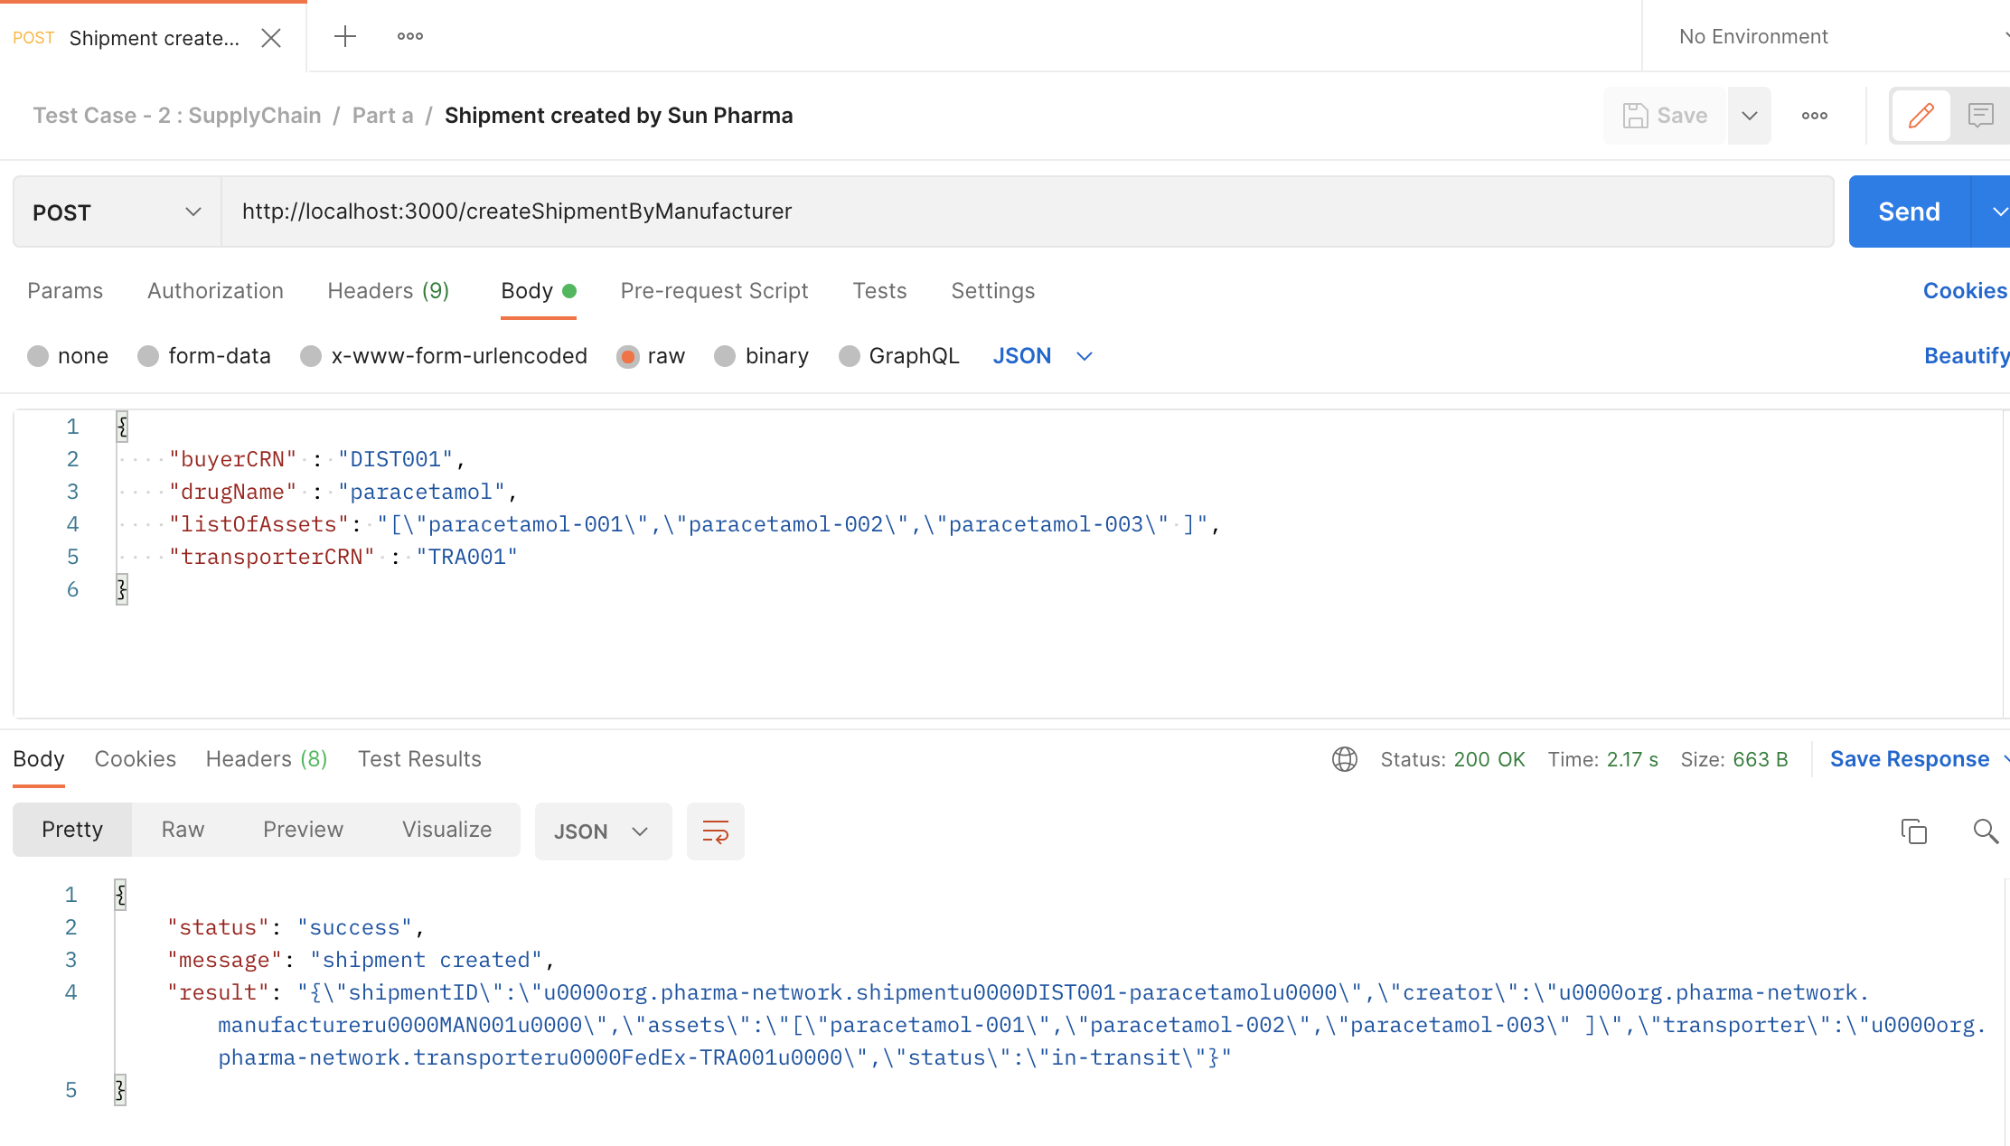

Shipment Delivered by FedEx,

curl --location --request POST 'http://localhost:3000/updateShipmentByTransporter' \

--header 'Content-Type: application/json' \

--data-raw '{

"buyerCRN" : "DIST001",

"drugName" : "paracetamol",

"transporterCRN" : "TRA001"

}'

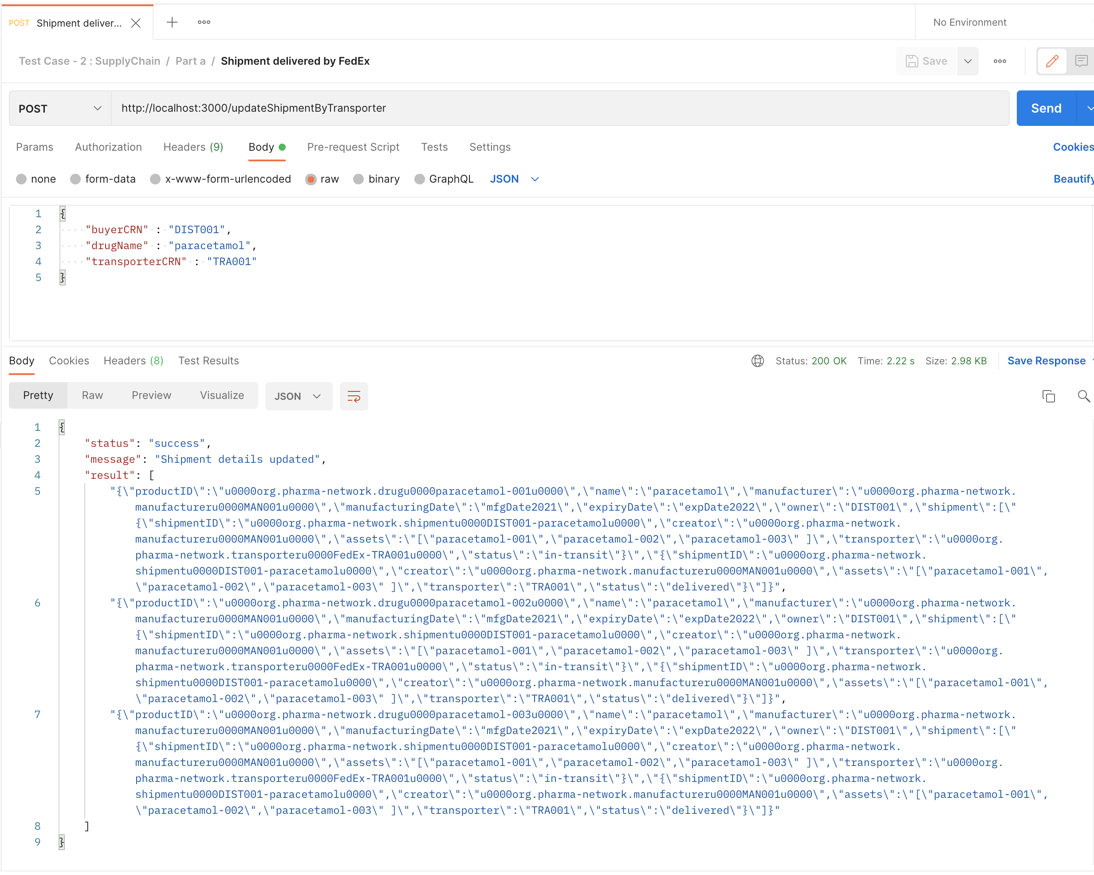

Part b :

Purchase Order by upgrad,

curl --location --request POST 'http://localhost:3000/createPOByRetailer' \

--header 'Content-Type: application/json' \

--data-raw '{

"buyerCRN" : "RET002",

"sellerCRN" : "DIST001",

"drugName": "paracetamol",

"quantity" : "2"

}'

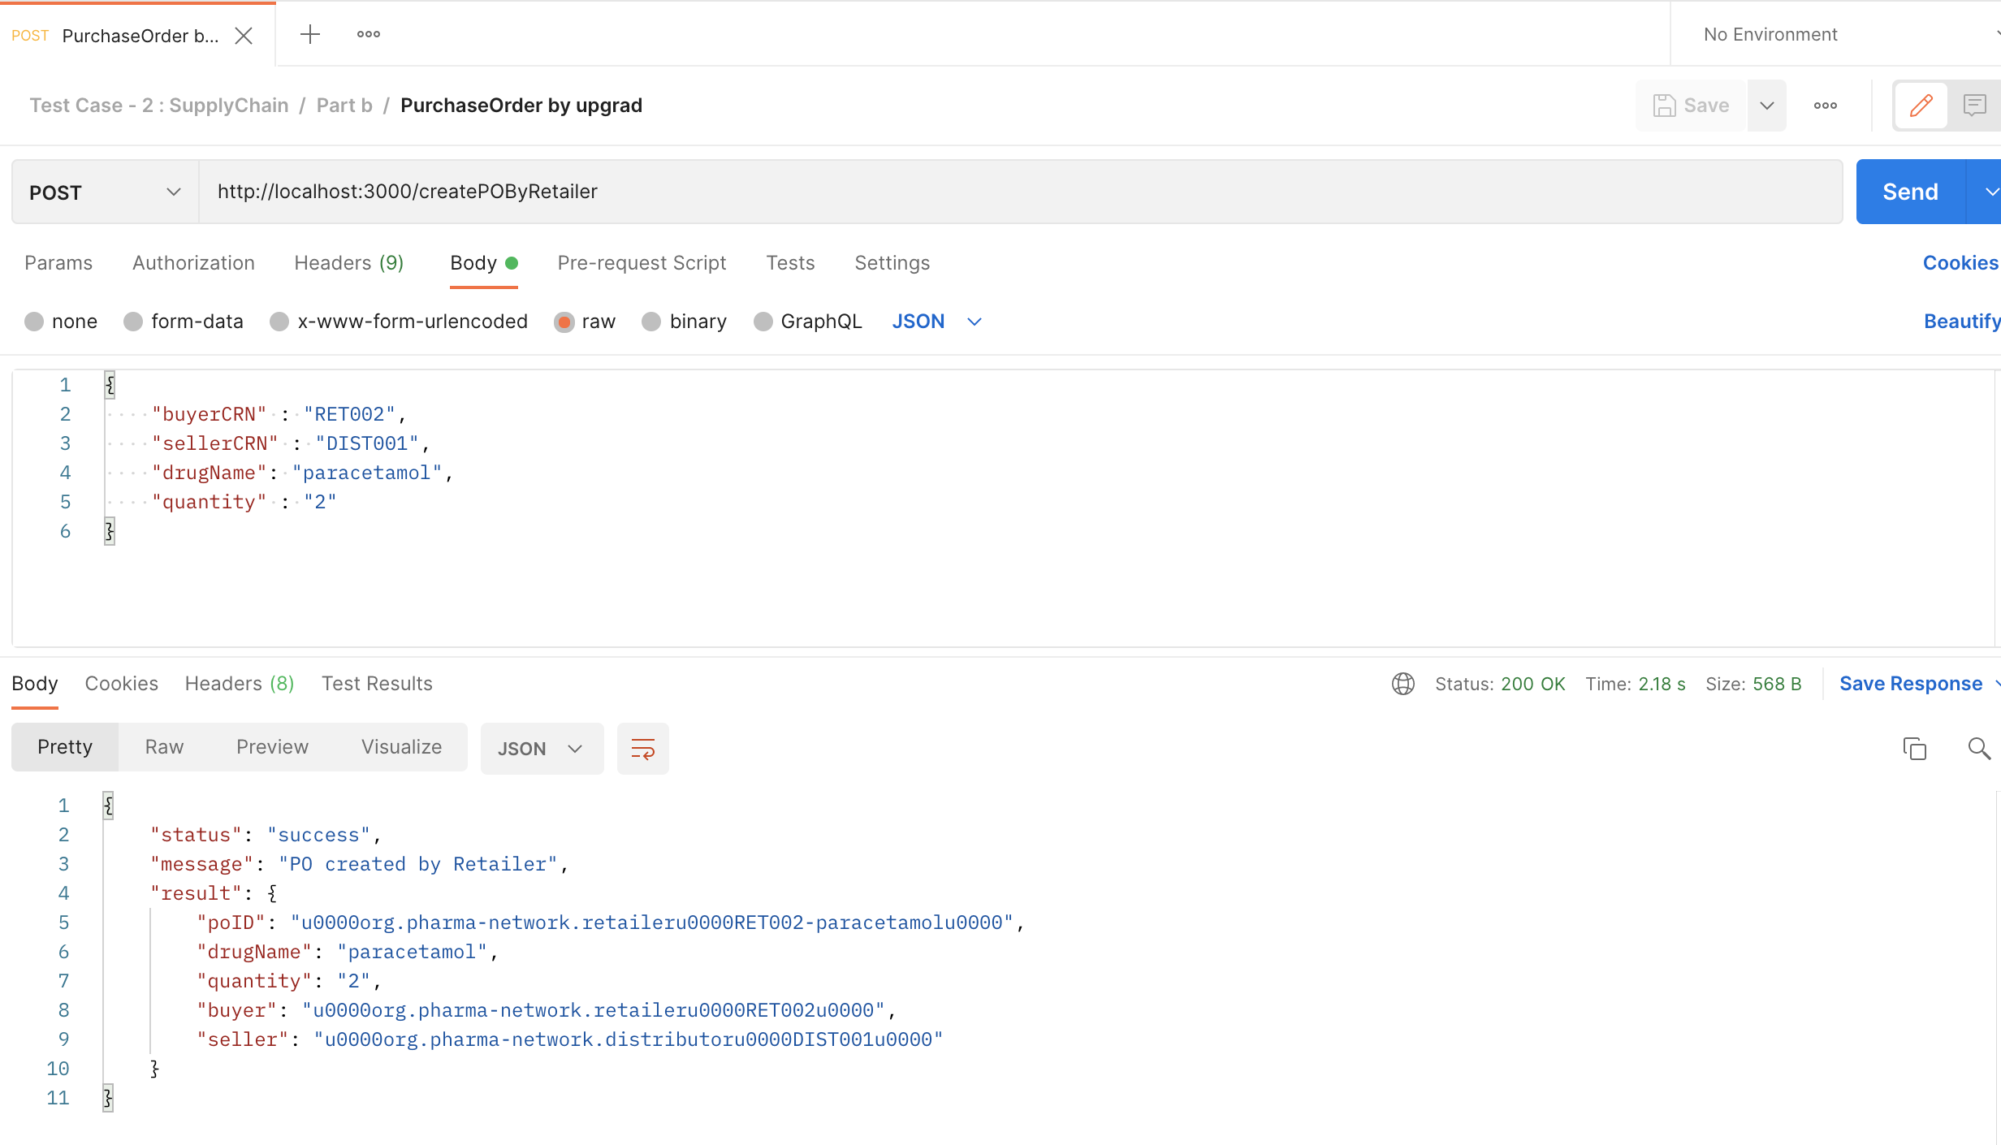

Shipment Created by VG Pharma,

curl --location --request POST 'http://localhost:3000/createShipmentByDistributor' \

--header 'Content-Type: application/json' \

--data-raw '{

"buyerCRN" : "RET002",

"drugName" : "paracetamol",

"listOfAssets": "[\"paracetamol-001\",\"paracetamol-002\" ]",

"transporterCRN" : "TRA002"

}'

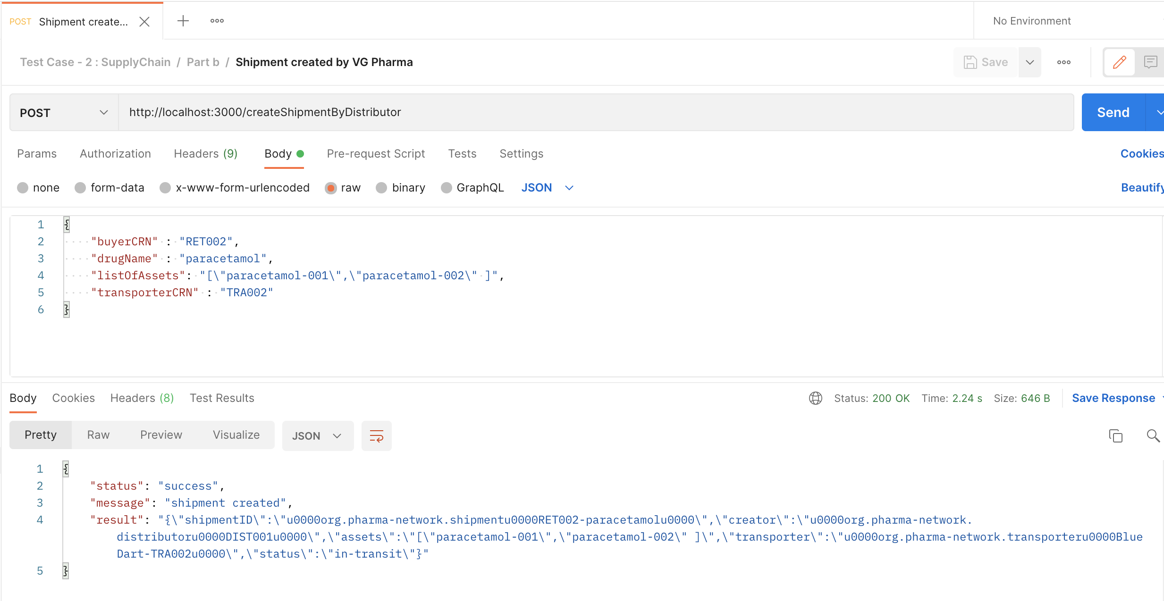

Shipment Delivered by BlueDart,

curl --location --request POST 'http://localhost:3000/updateShipmentByTransporter' \

--header 'Content-Type: application/json' \

--data-raw '{

"buyerCRN" : "RET002",

"drugName" : "paracetamol",

"transporterCRN" : "TRA002"

}'

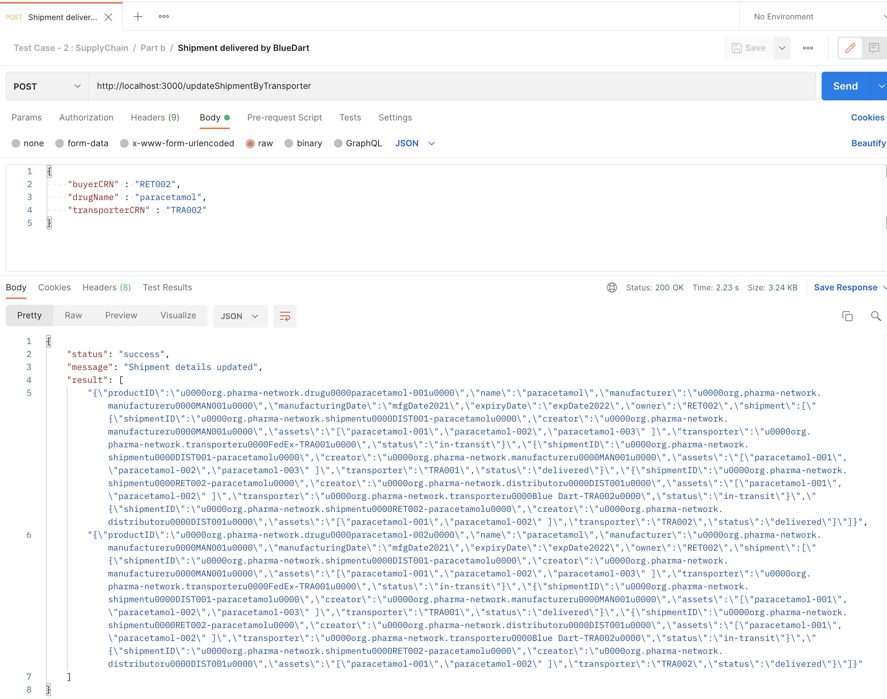

Part c,

Consumer Akash buying Drug : 001

curl --location --request POST 'http://localhost:3000/retailDrugByRetailer' \

--header 'Content-Type: application/json' \

--data-raw '{

"drugName" : "paracetamol",

"serialNo" : "001",

"retailerCRN": "RET002",

"customerAadhar" : "AAD001"

}'

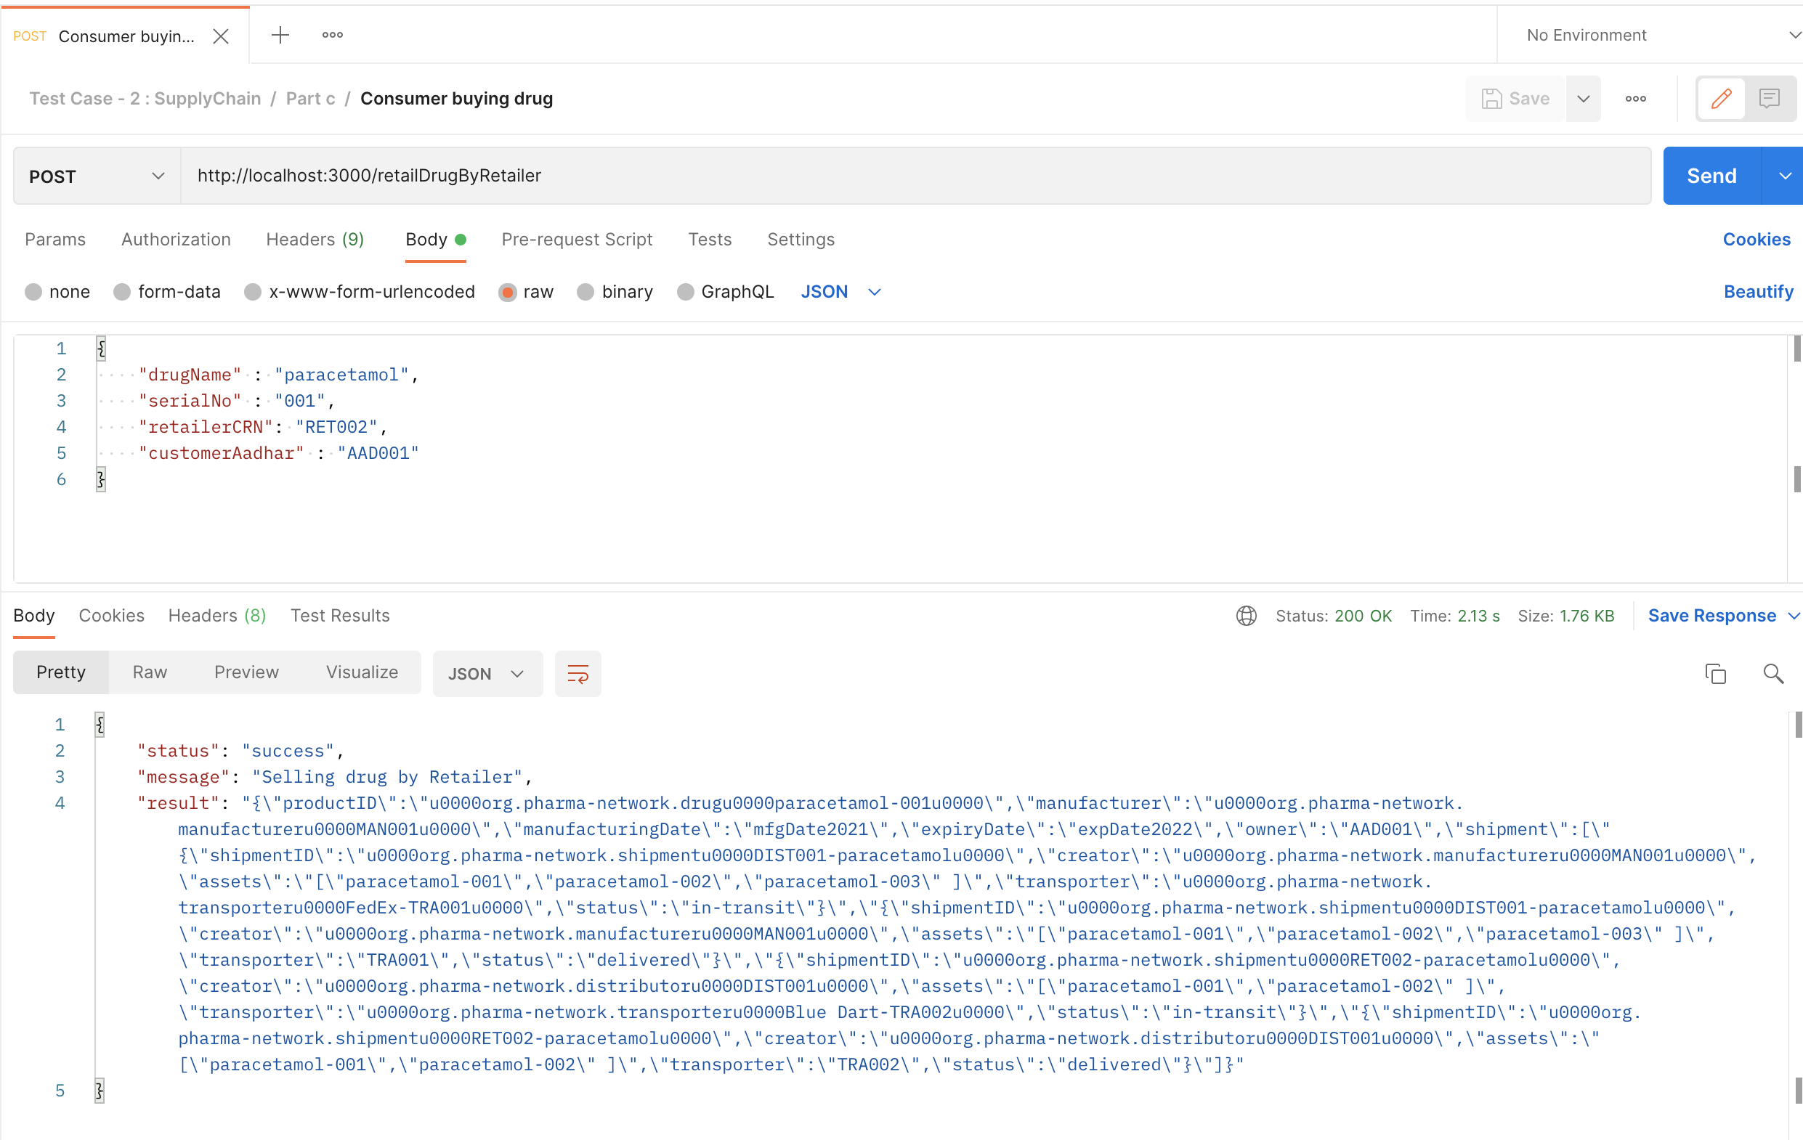

Test Case 3:

View Drug current state by Consumer Akash,

curl --location --request GET 'http://localhost:3000/viewDrugCurrentStateByConsumer' \

--header 'Content-Type: application/json' \

--data-raw '{

"drugName" : "paracetamol",

"serialNo" : "001"

}'

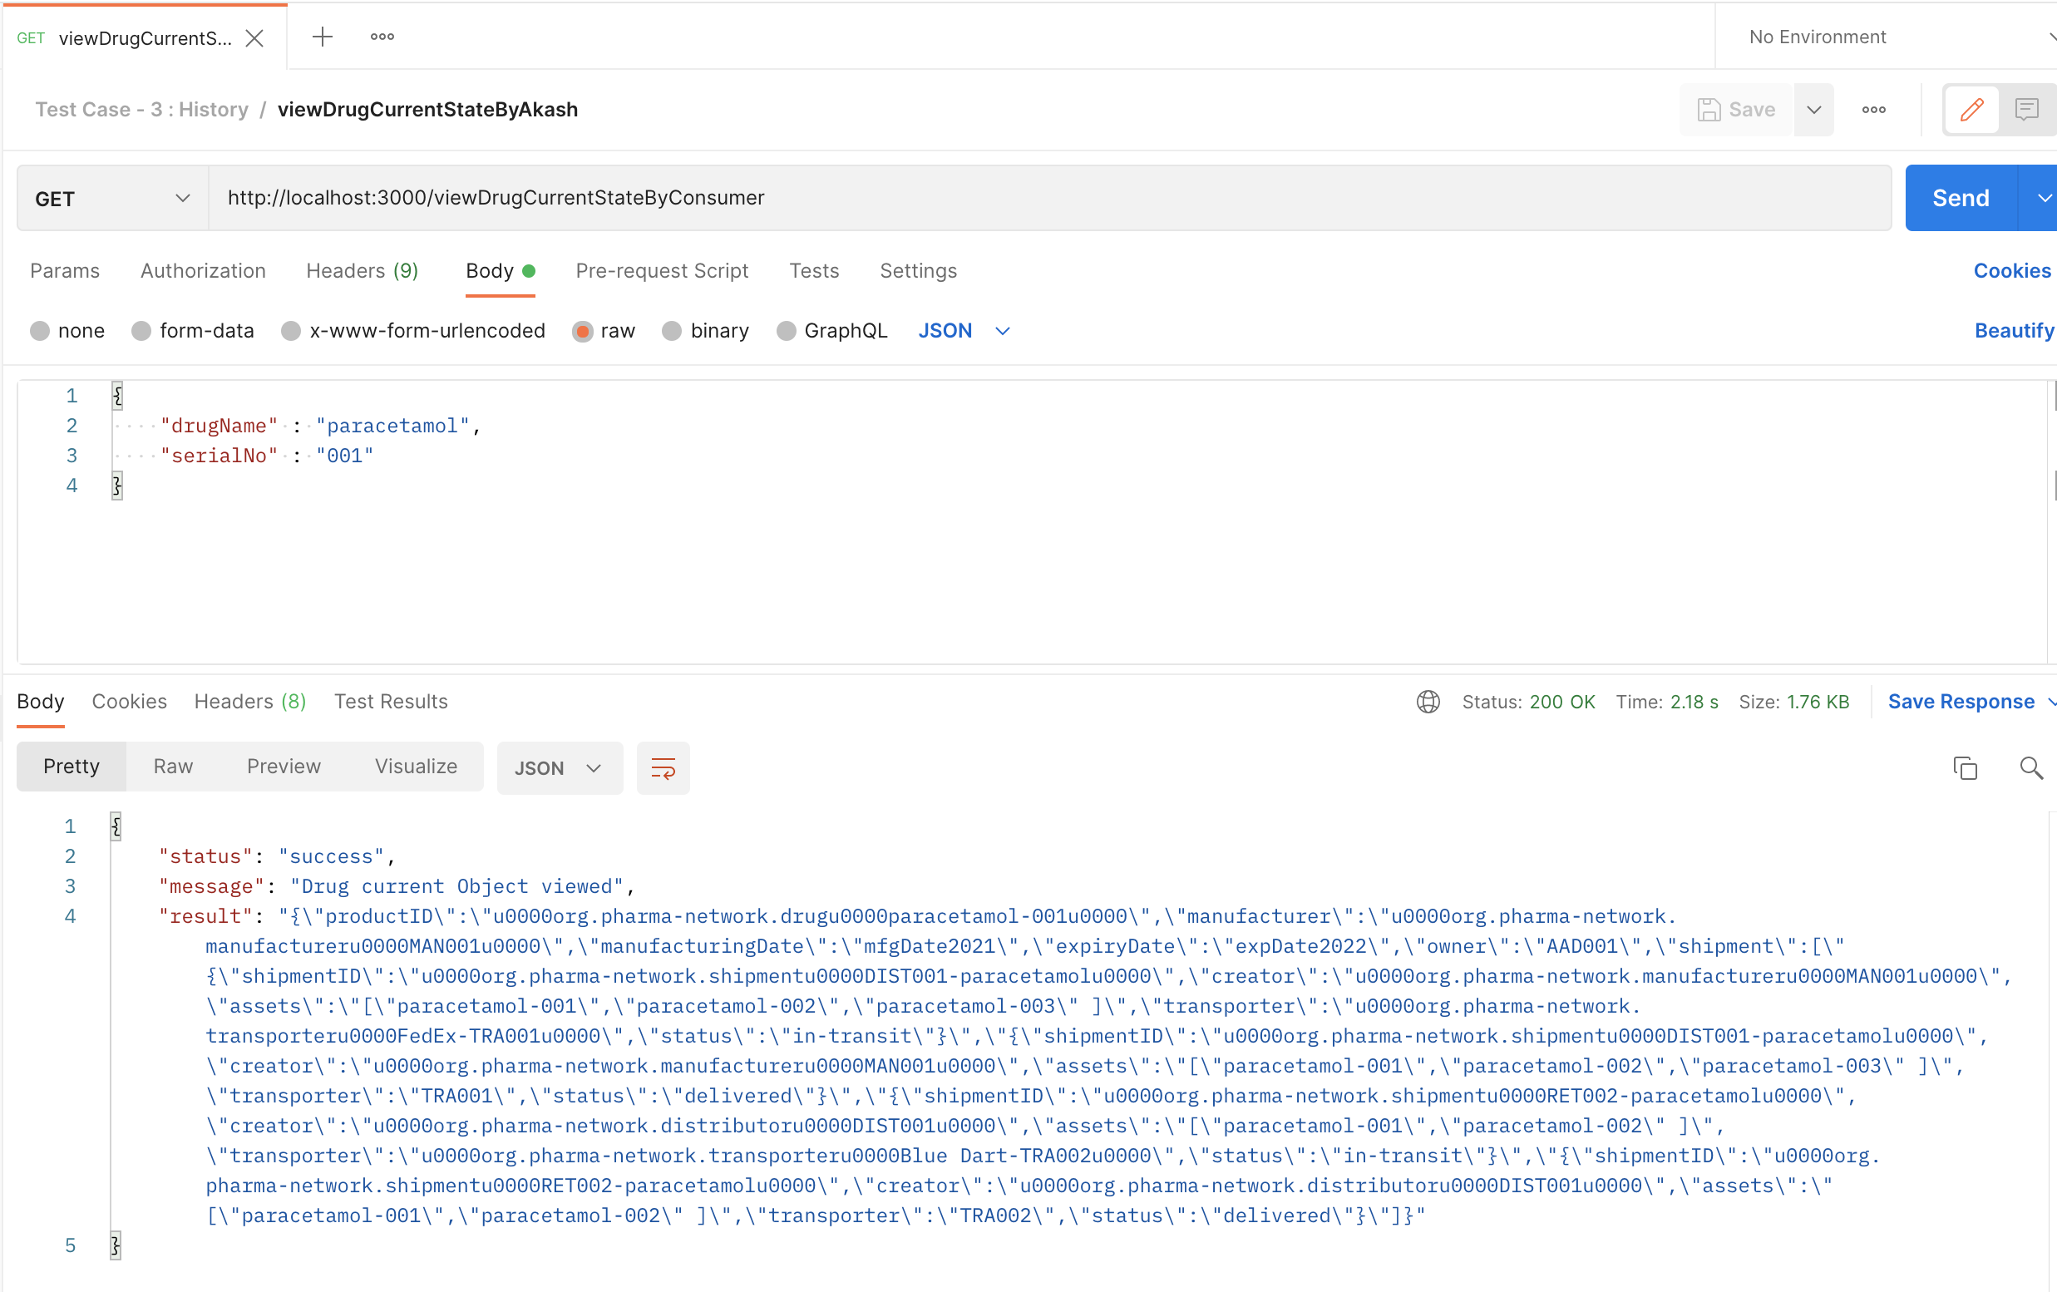

View Drug History by Consumer Akash,

curl --location --request GET 'http://localhost:3000/viewHistoryByConsumer' \

--header 'Content-Type: application/json' \

--data-raw '{

"drugName" : "paracetamol",

"serialNo" : "001"

}'

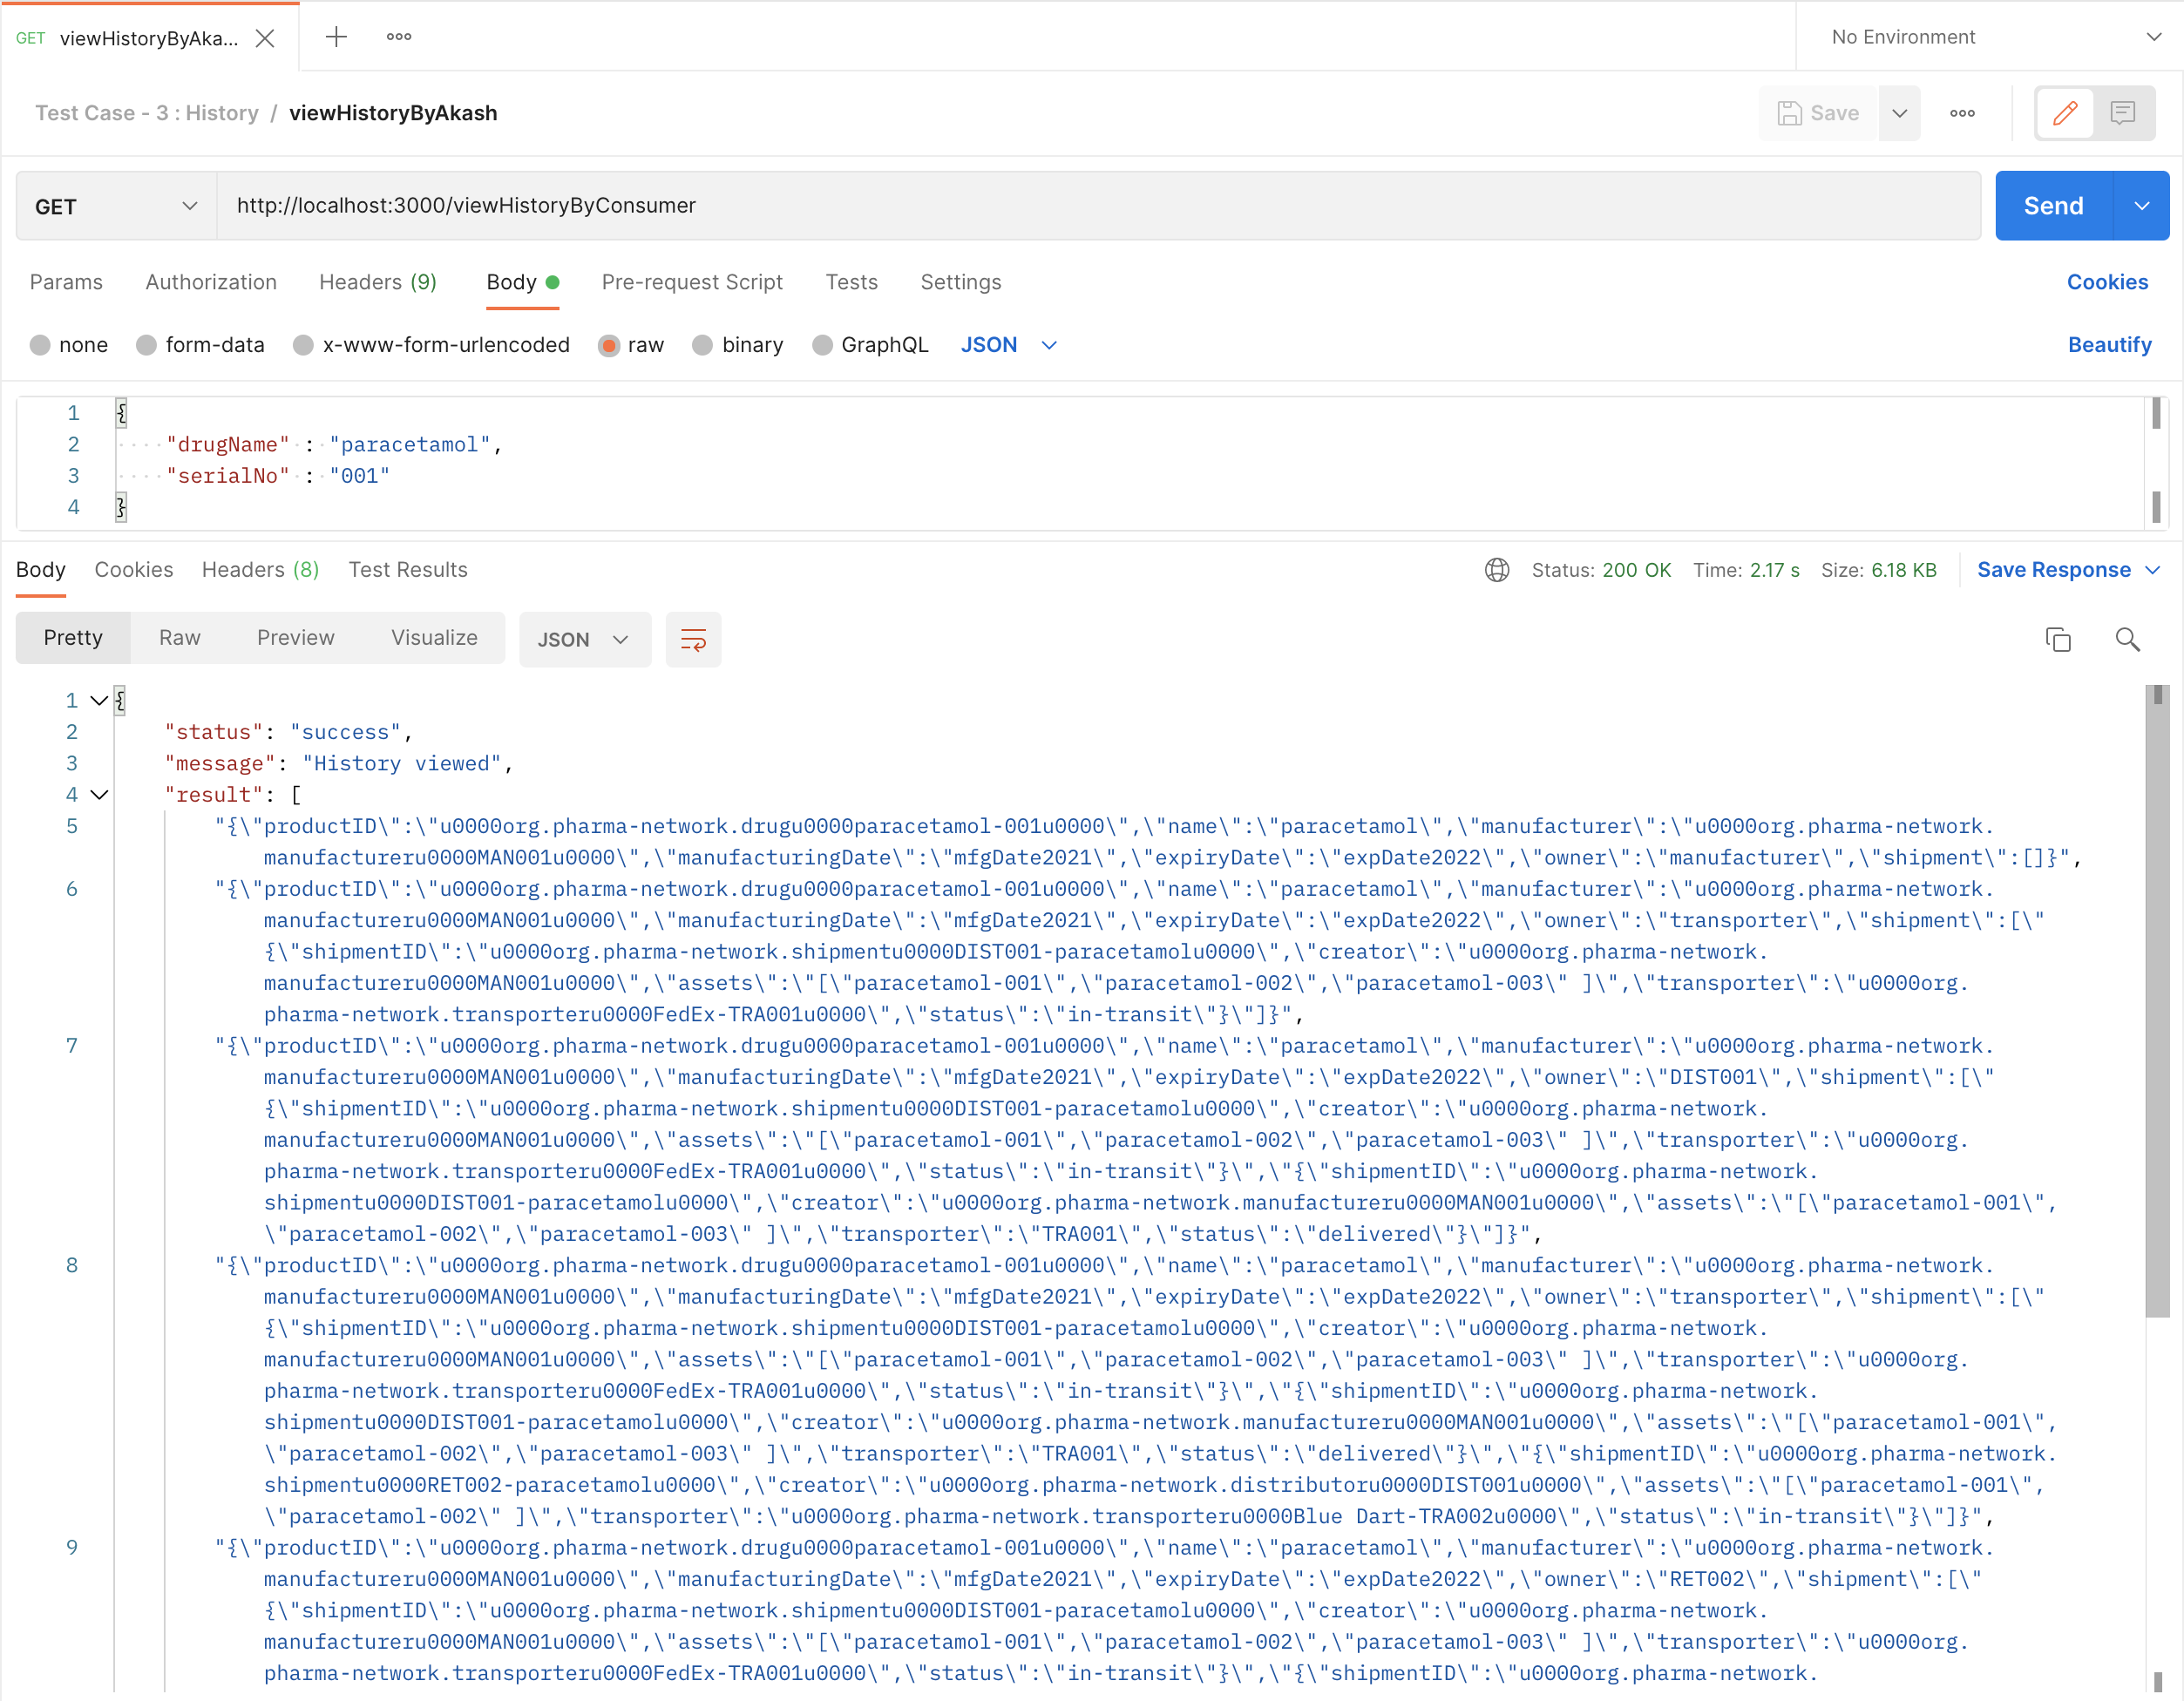

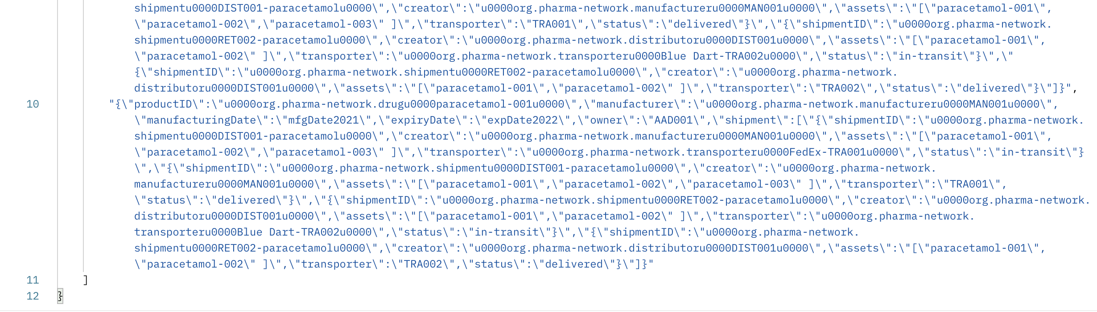

Below screenshot is of terminal which populates when request is triggered from postman,

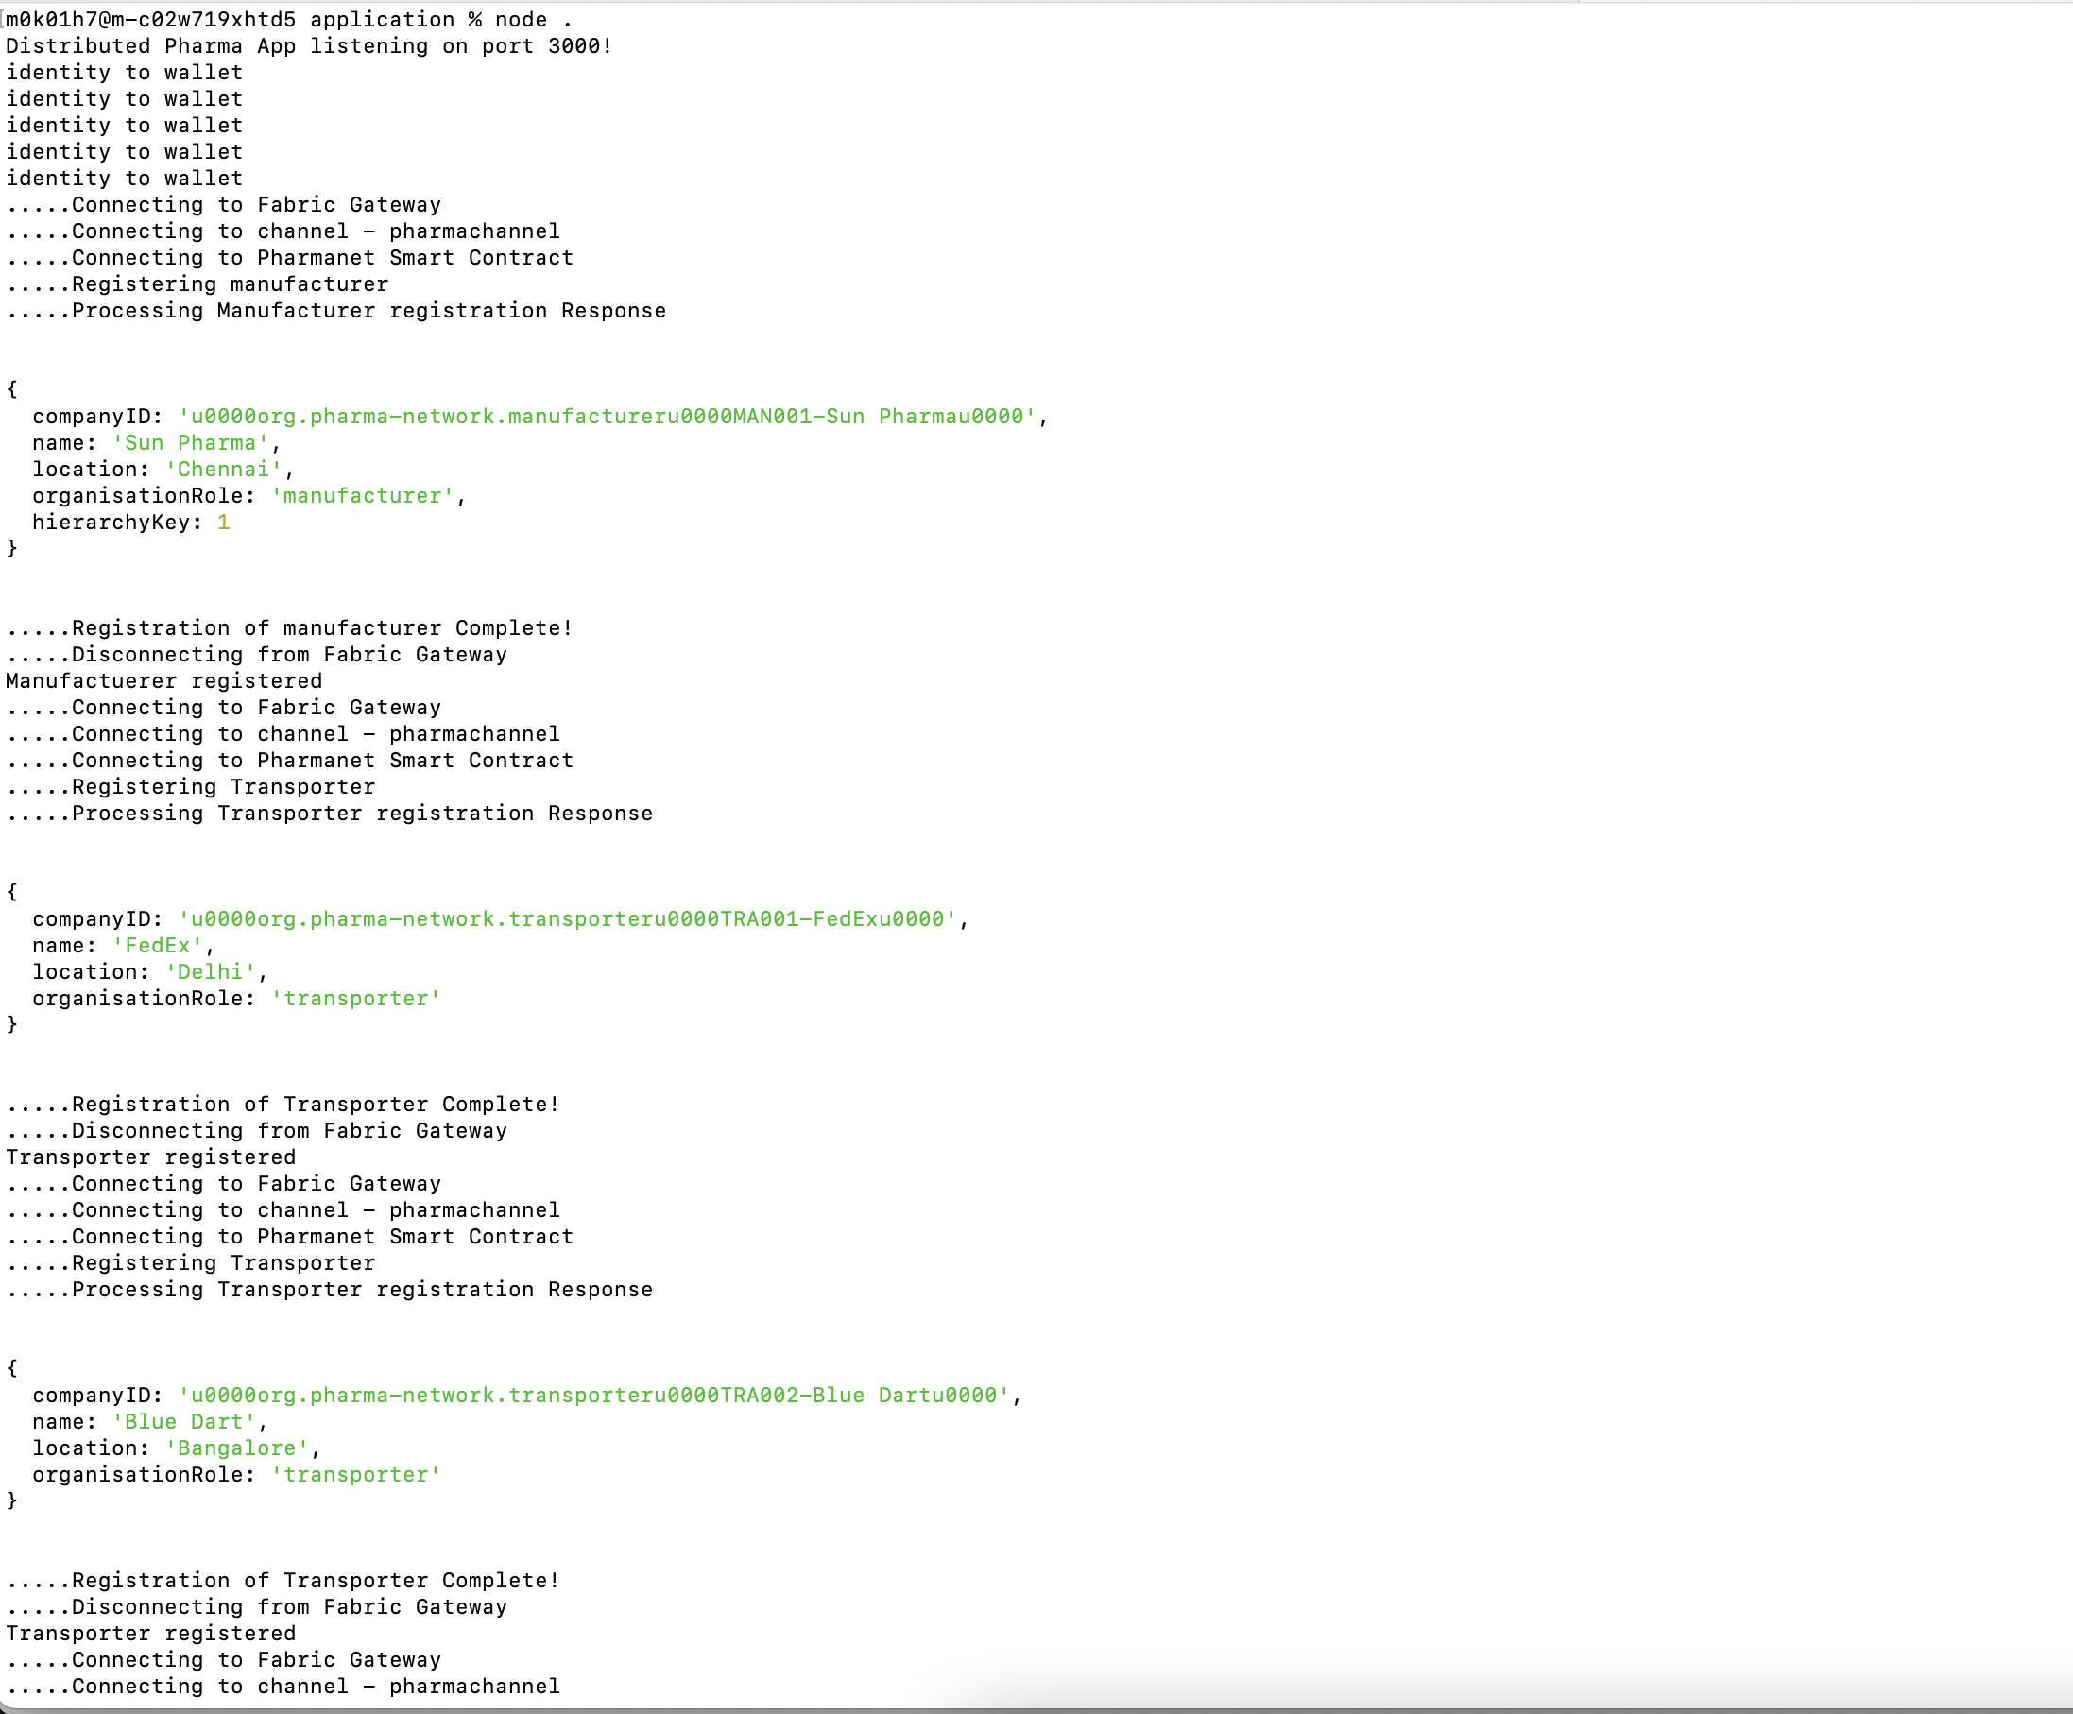

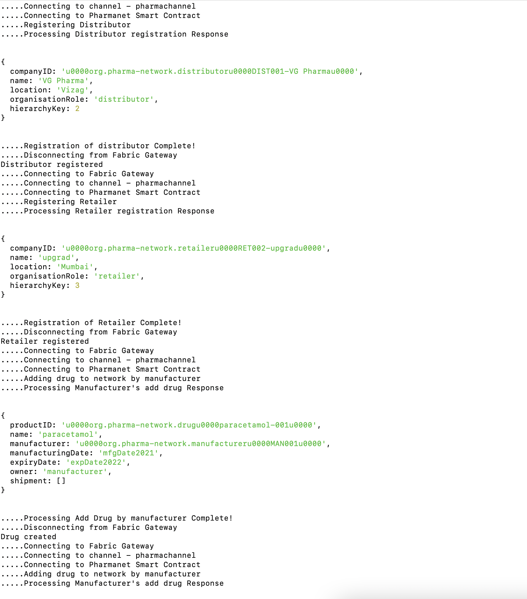

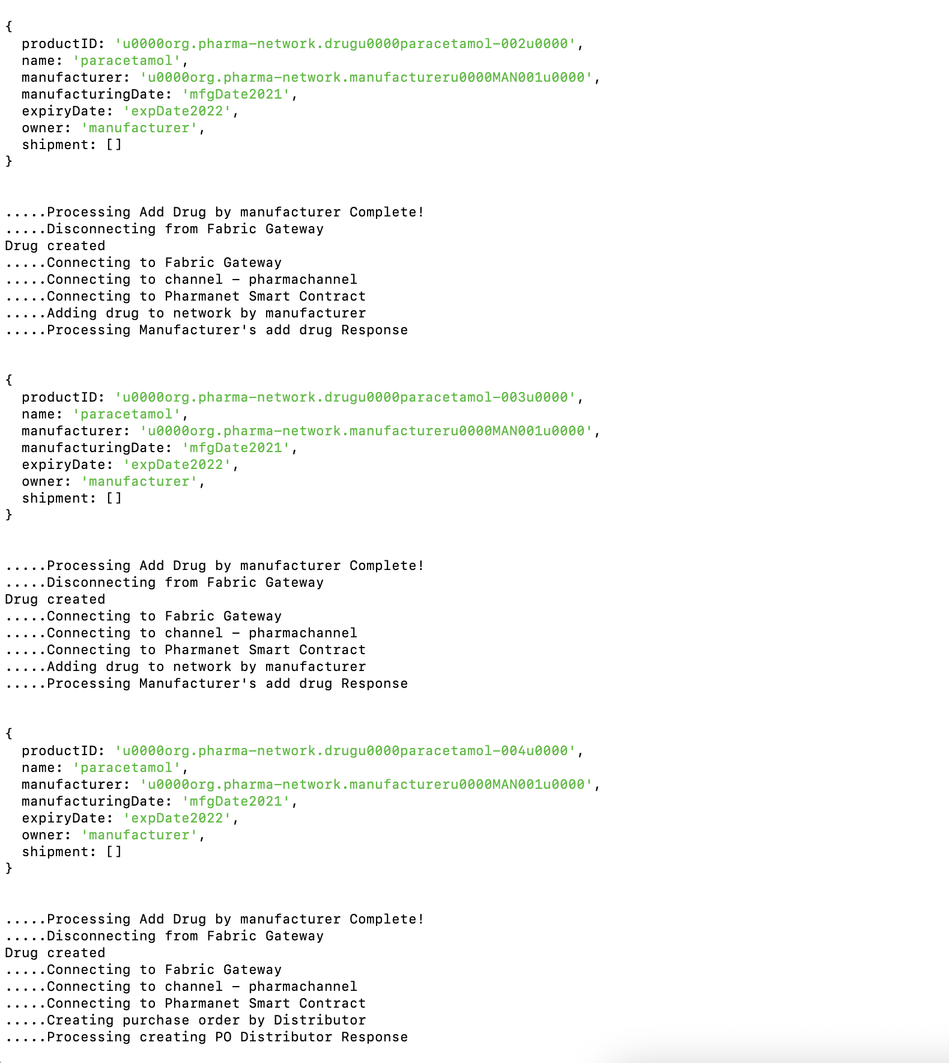

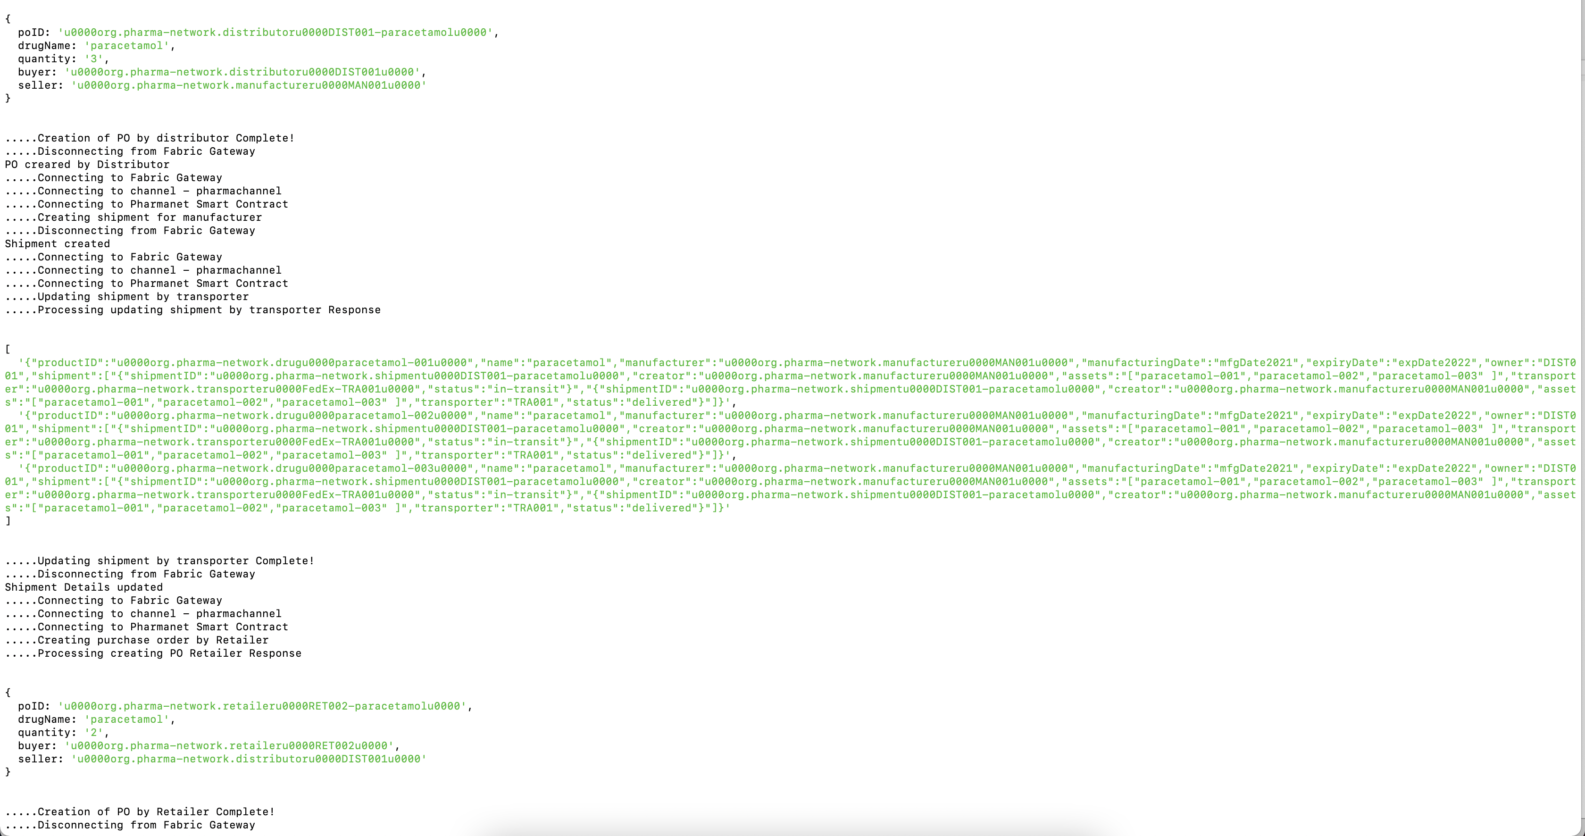

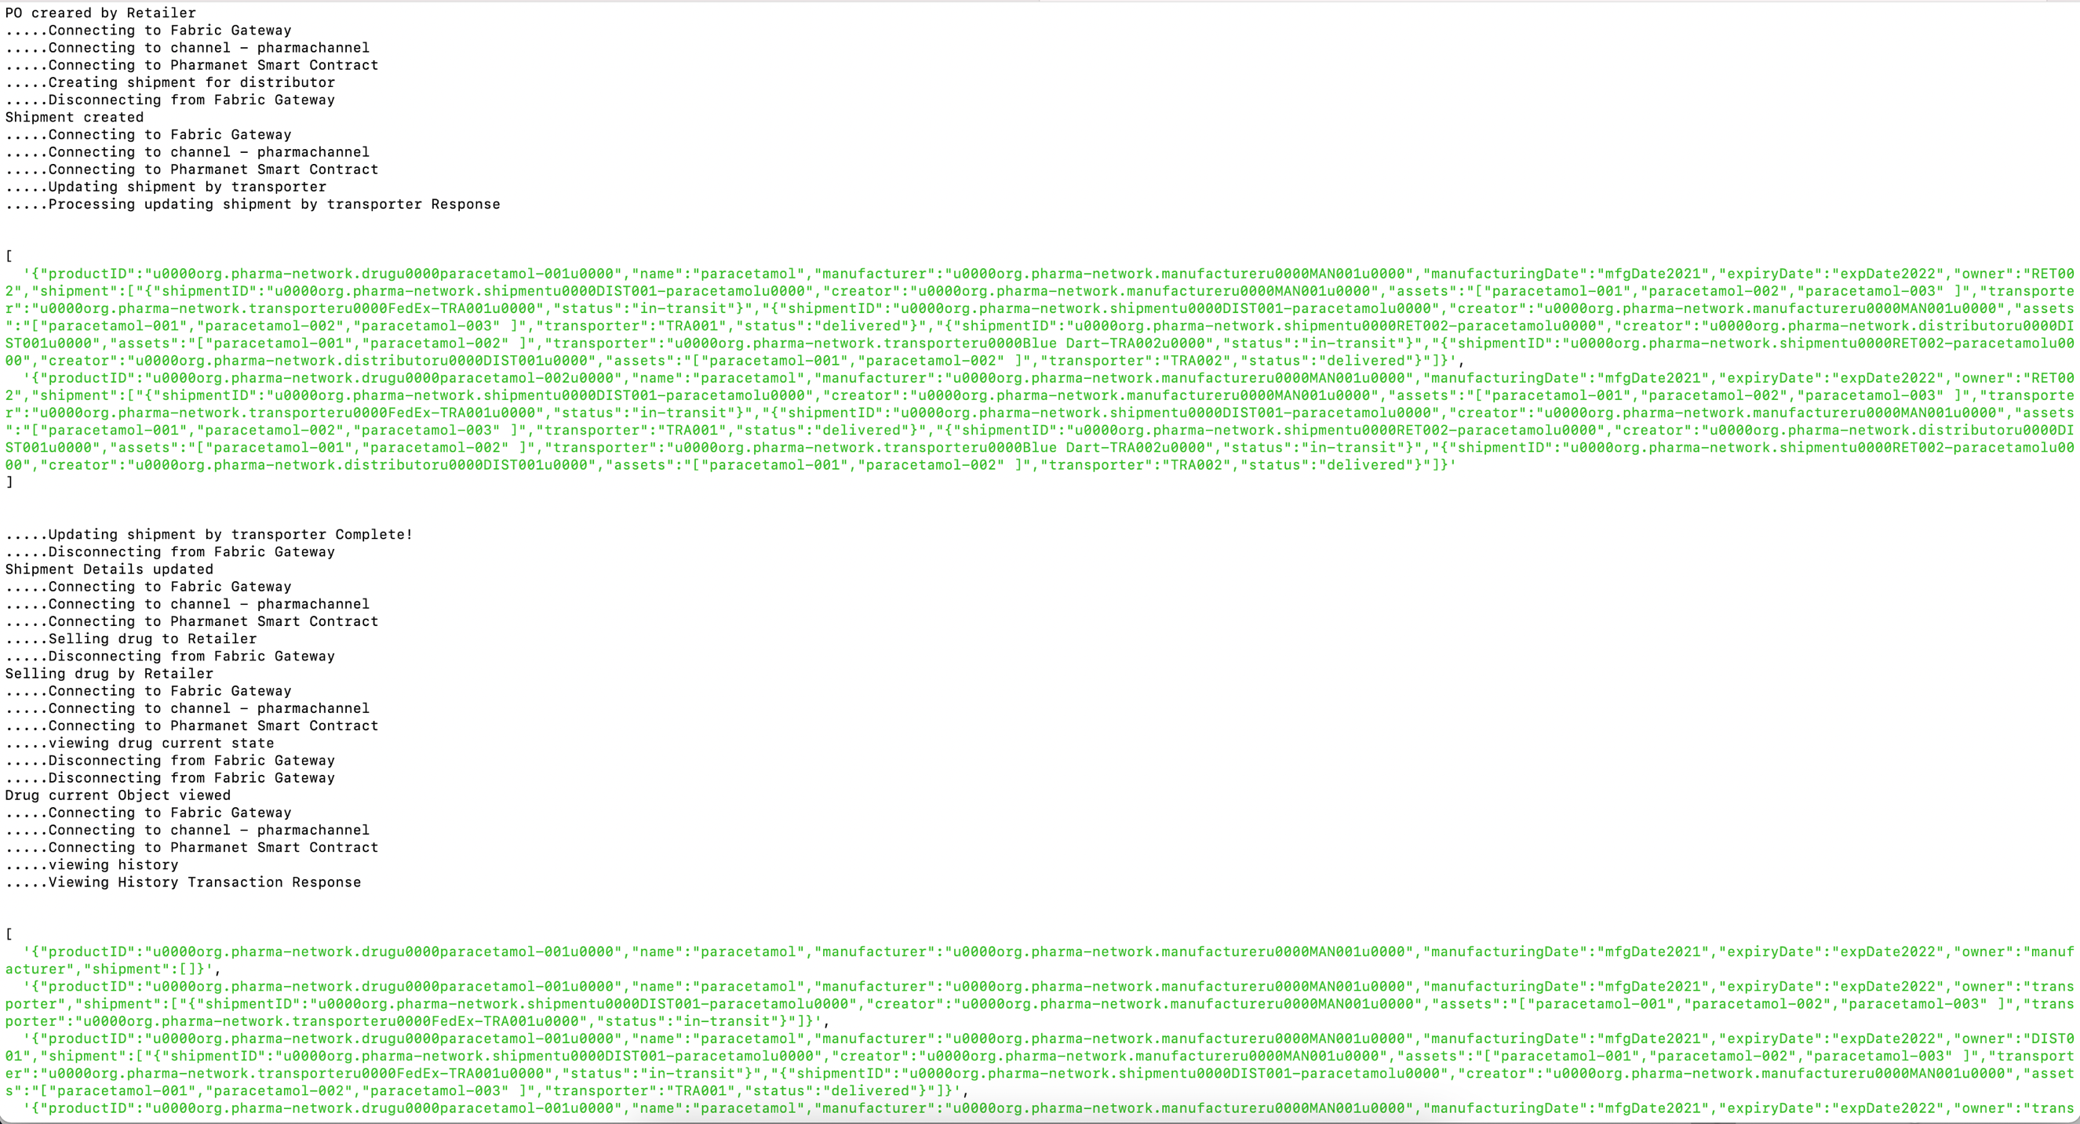

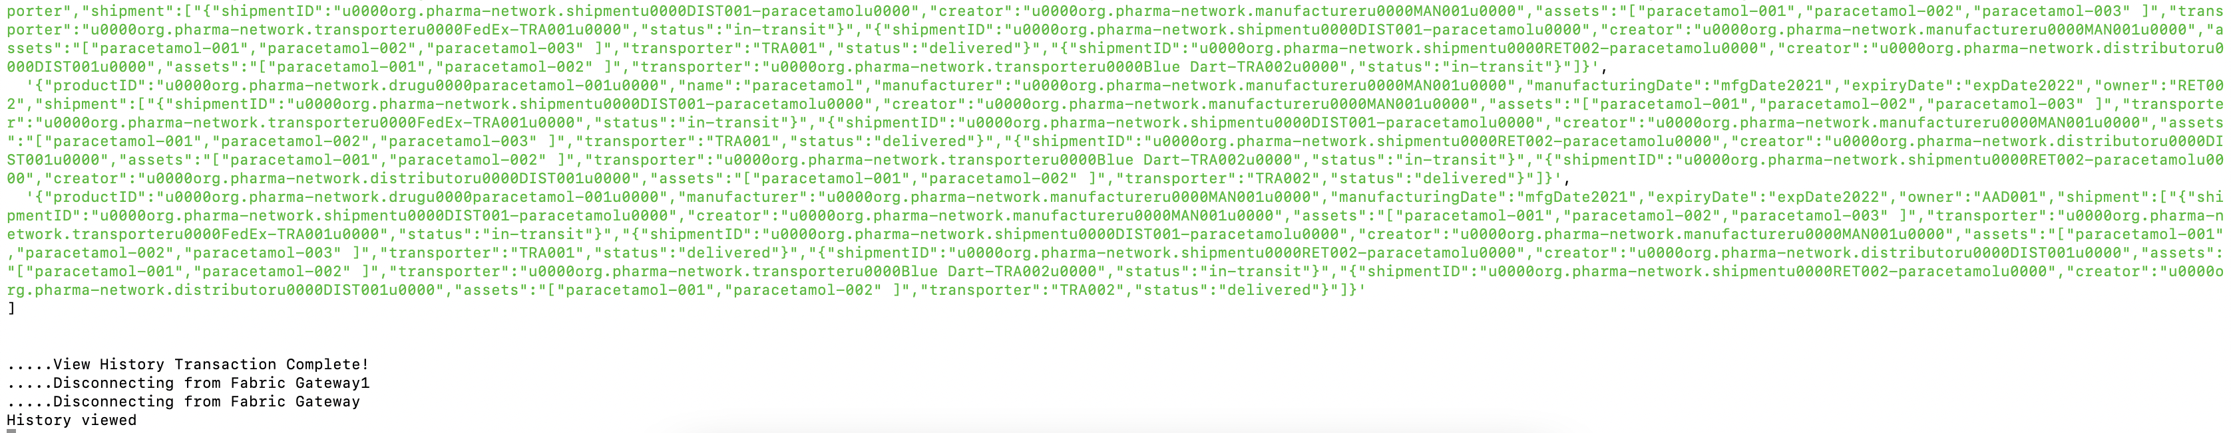

Following negative scenarios were also tested:

Re-registration of Org: throwing error as already registered, This is applicable for all organizations, here gave only 1 example

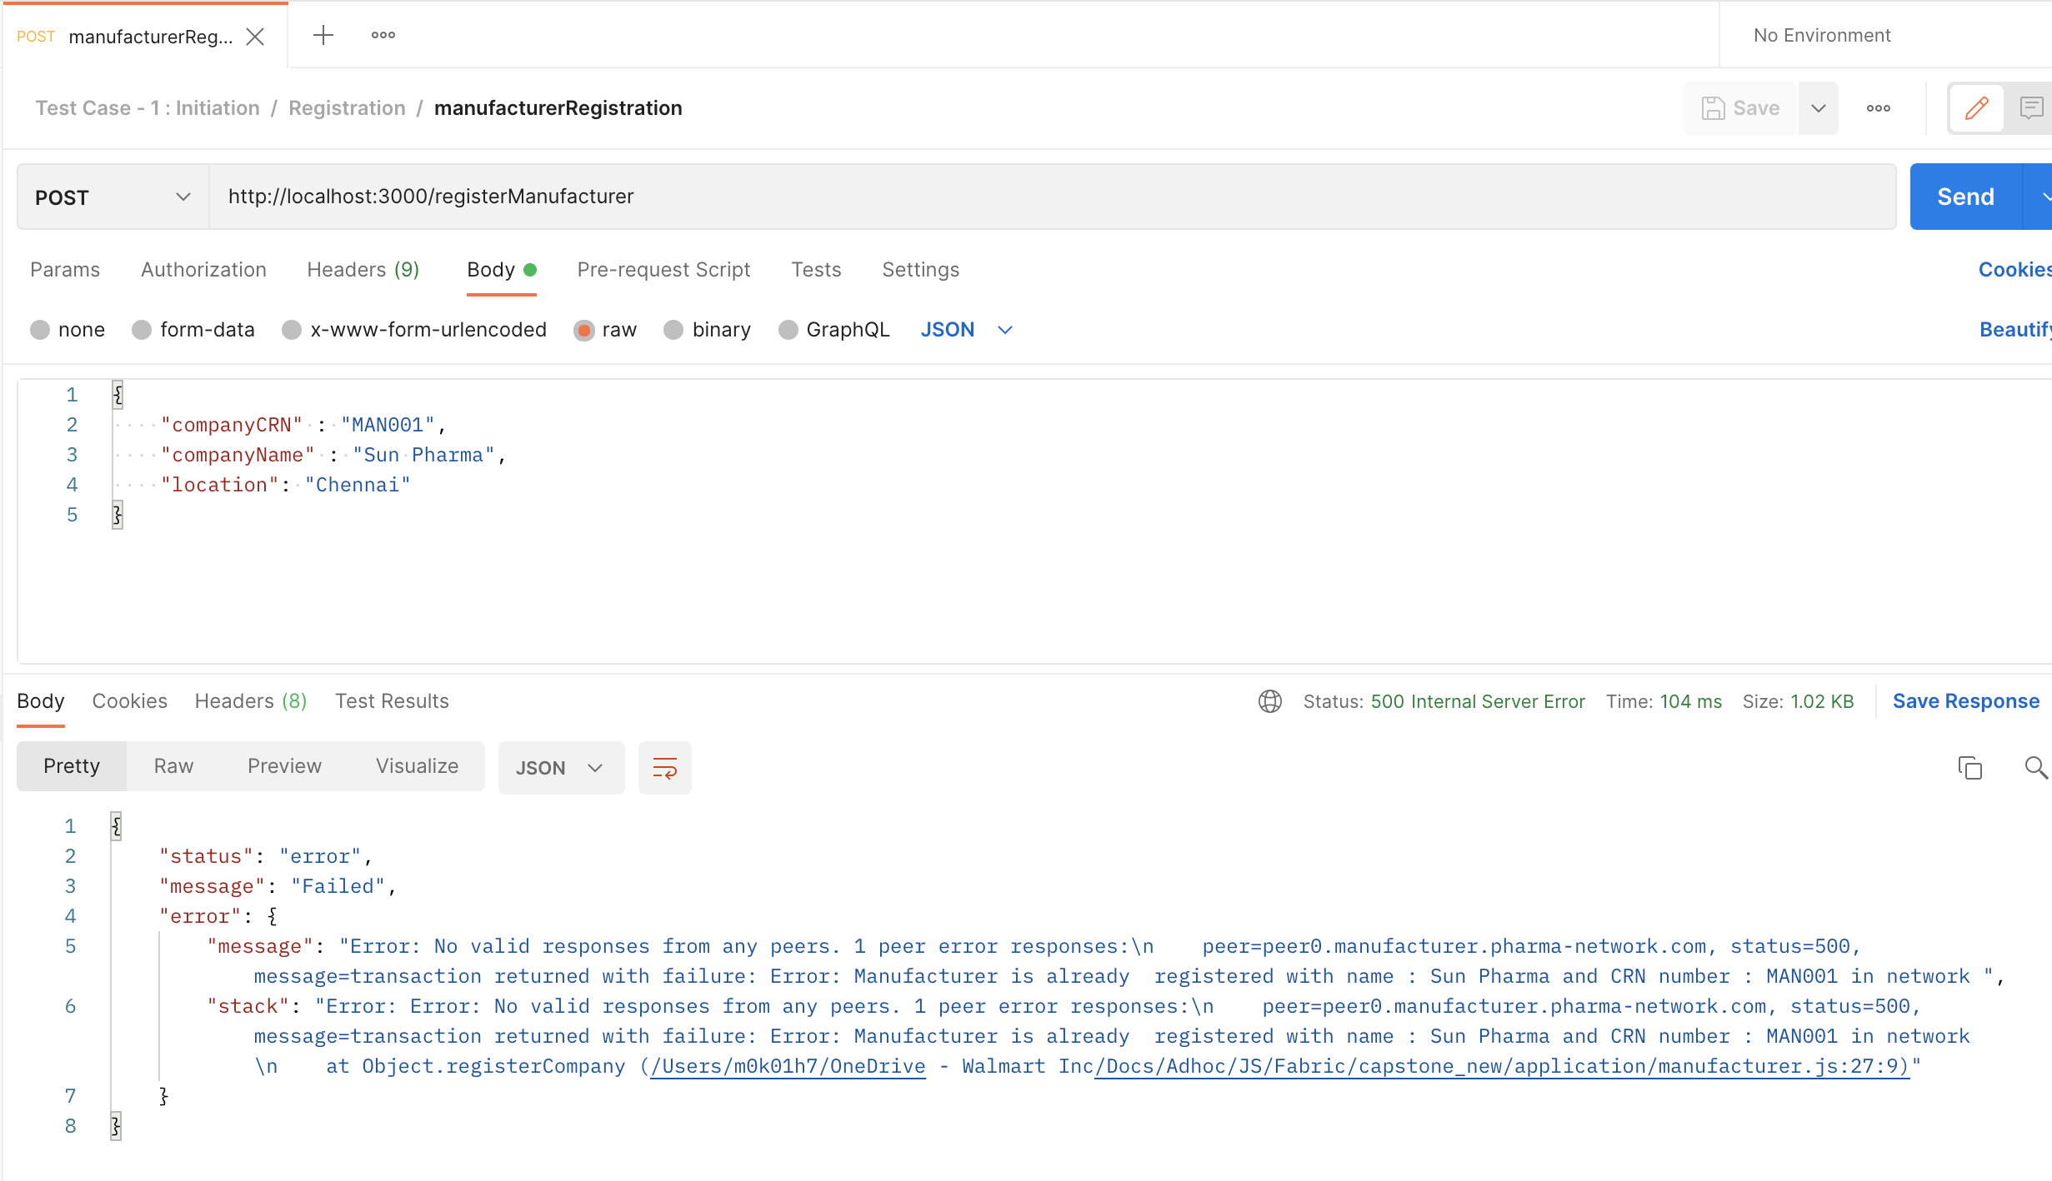

Before creating shipment object:

check if Buyer is in network,

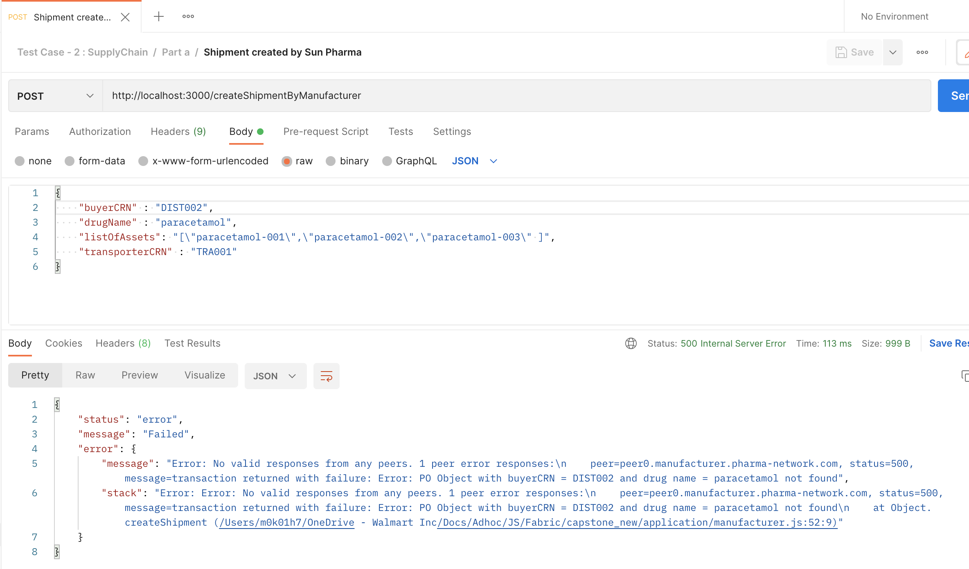

check if transporter is in network,

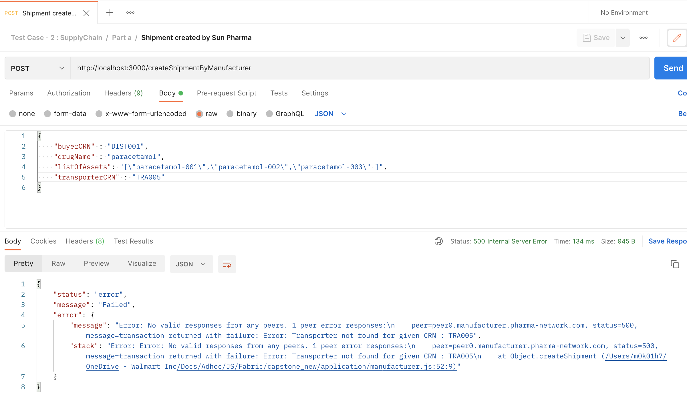

Before creating shipment object, check if quantity raised as part of PO is same as list of assets,

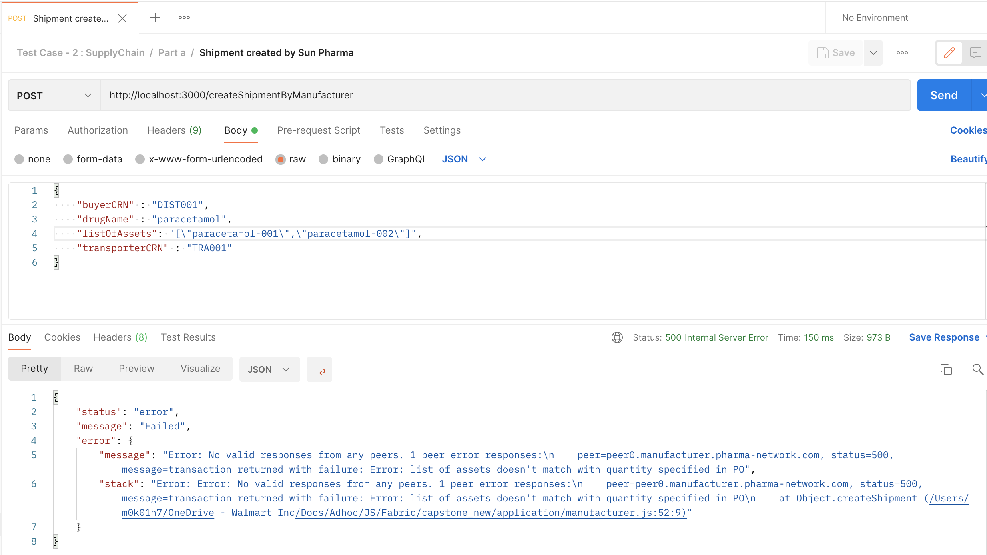

As part of creation of shipment object, check if list of assets specified In request are in network,

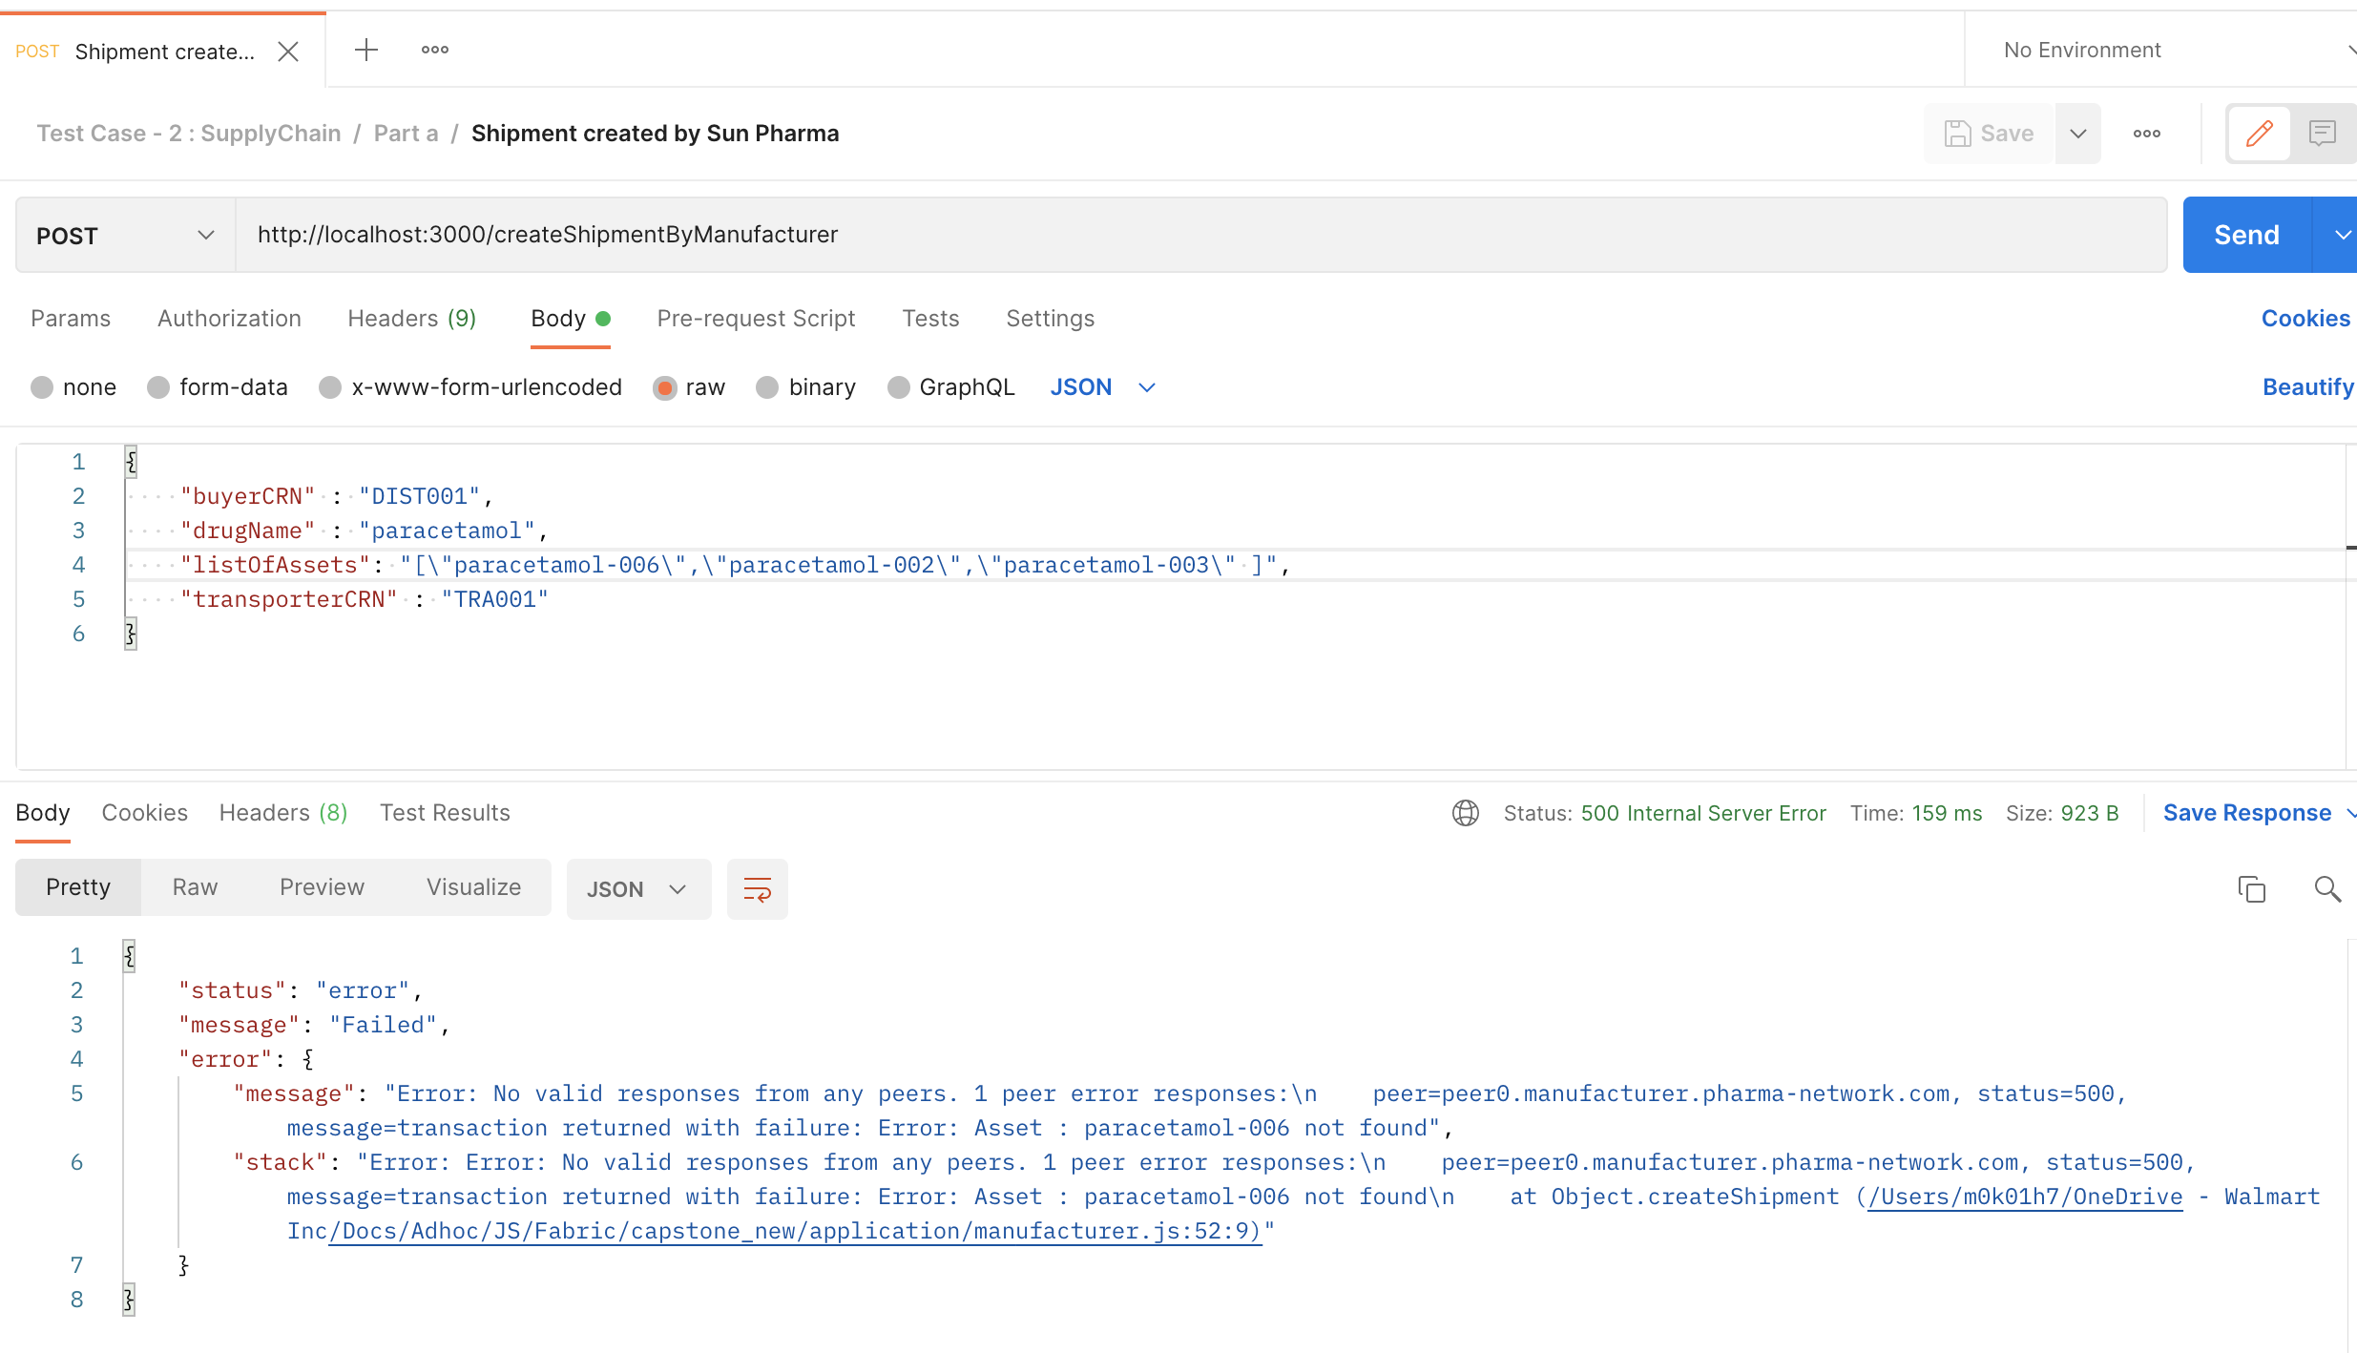

Before adding drug to network, check if drug with given serial number is already in network,

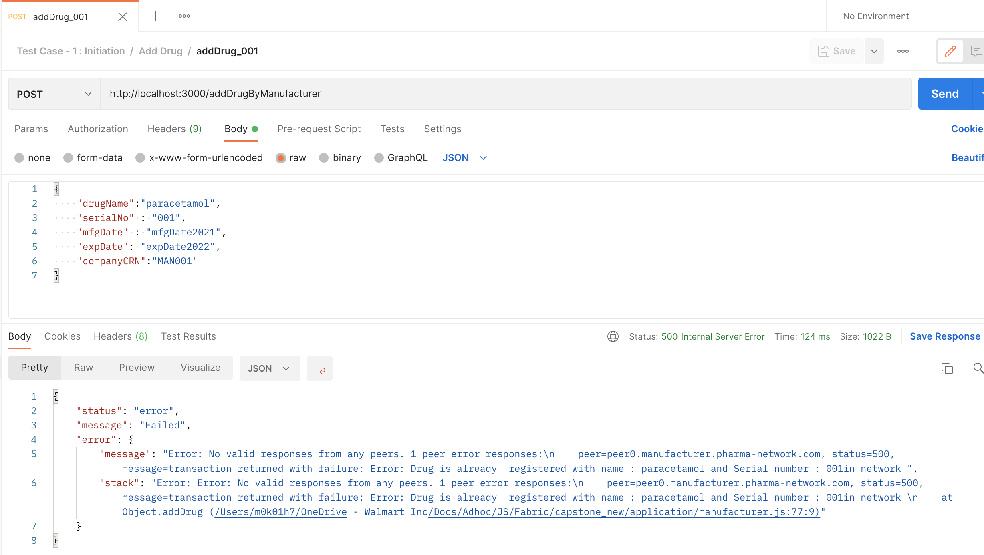

Note : I have created contracts specific to Org, so for functions there was no need to pass Org as function argument.